Dissertation

1. List the key findings – one sentence each, order from most exciting to least, or another logical order
2. Make figures for each key finding – place in pre-determined order
3. Write results around each finding – place in pre-determined order
4. Write methods around each result – only include methods needed to describe the science leading to the results presented
5. Write first paragraph of discussion – summarise all the key findings in order
6. Write the last paragraph of the intro – describes the research questions, hypotheses and/or objectives of the study – the study roadmap
7. Write the next paragraphs of the discussion – one paragraph per each key finding in order, discussions often also include a study limitations paragraph and a future research directions paragraph
8. Write the introduction paragraphs – one paragraph per topic of each of the key findings, should match with the content in the discussion paragraphs
9. Write the first paragraph of the introduction – provides the big picture context and sets out the clear knowledge gap of the study.
10. Write the conclusion paragraph – the last paragraph of the discussion or it’s own section, should explain why the research matters and put the key findings back into the big picture context set out in the first paragraph of the intro
11. Write the abstract – should include your entire pitch and should ideally follow the Nature abstract structure

**Need to go over all my hypothesis and check that the are correct and CONSISTNET thoughout diss**

**Abstract** – Ignore Abstract!!!!

1. a 1.5 line-spaced summary of not more than 250 words. This should contain:
   * a description of the research question/knowledge gap – what we know and what we don’t know
   * how your research has attempted to fill this gap
   * a brief description of the methods
   * brief results
   * key conclusions that put the research into a larger context

Remote sensing is an important tool for mapping and monitoring vegetation. Advances in sensor technology continually improve the information content of imagery for airborne, as well as space-borne, systems. This paper investigates whether vegetation associations can be differentiated using hyperspectral reflectance in the visible to shortwave infrared spectral range, and how well species can be separated based on their spectra. For this purpose, the field reflectance spectra of 27 saltmarsh vegetation types of the Dutch Waddenzee wetland were analysed in three steps. Prior to analysis, the spectra were smoothed with an innovative wavelet approach.

In the first stage of the analysis, the reflectance spectra of the vegetation types were tested for differences between type classes. It was found that the reflectance spectra of saltmarsh vegetation types are statistically significantly different for various spectral regions.

Secondly, it was tested whether this statistical difference could be enhanced by using continuum removal as a normalisation technique. For vegetation spectra, continuum removal improves the statistical difference between vegetation types in the visible spectrum, but weakens the statistical difference of the spectra in the near-infrared and shortwave infrared part of the spectrum.

Thirdly, after statistical differences were found, it was determined how distant in spectral space the vegetation type classes were from each other, using the Bhattacharyya (BH) and the Jeffries–Matusita (JM) distance measures. We selected six wavelengths for this, based on the statistical analysis of the first step. The potential of correct classification of the saltmarsh vegetation types using hyperspectral remote sensing is predicted by these distance measures.

It is concluded that the reflectance of vegetation types is statistically different. With high quality radiometric calibration of hyperspectral imagery, it is anticipated that vegetation species may be identified from imagery using spectral libraries that were measured in the field during the time of image acquisition.

Changes in plant communities are one of the most distinct responses to global climate change, yet we lack quantification of plant diversity and composition in the biome experiencing the highest rate of warming – the Arctic. Global ecological processes are driven by the diversity and composition of vegetation communities. Plants are critical to providing a multitude of functions, such as building the foundation of trophic food chains, supporting the existence of other organisms, as well providing essential ecosystem services (Cavender‐Bares et al., 2017). The efficient assessment of plant community’s composition and richness is of global importance, as currently one in five plant species is currently categorized as threatened by extinction (Royal Botanic Gardens, 2016). Traditional methods of measuring biodiversity involve field studies and visual surveys, which are both resource intensive and limited in their spatial and temporal resolution (Schweiger et al., 2017). The synthesis of remotely sensed earth observation data with local climatic and topographical conditions, presents itself as a potential cost-effective and standardized technique to monitor real-time changes on an ecosystem, or even global scale (Rocchini et al., 2010). Yet, the general feasibility of using remote sensing for even local static biodiversity evaluations still remains unclear, precluding the development of the envisioned global monitoring networks of spatial-temporal change.

sort positive and negative results (not chronologically)

**Table of Contents**

this should list all chapter headings and sub-headings. All should be numbered, e.g. 1. Introduction, 1.1 Background to the dissertation topic, etc.

**Acknowledgements**

I would like to thank Dr. Isla Myers-Smith for her guidance, insight, and advice at all stages of this dissertation. I am thankful for having her as a supervisor. A special thanks goes to Gergana Daskalova for her continuous support, thoughtful feedback, and expert advice in finessing my visualizations. Her passion inspired me pursue goals that I did not think I could achieve. I would like to thank all the remaining Team Shrub members for their feedback and insights that helped shape and improve my dissertation at all its stages. I would also like to acknowledge all those to who conducted fieldwork on Qikiqtaruk and collected the data, without which, this dissertation would not have been possible. I am thankful to Dr. Alison Beamish, for sharing her expertise when sorting through spectral data and her quick enthusiasm to help address new questions.

A final thanks goes Kimberley Schneidereit: without her continuous support, I would have not been able to have made it this far.

**List of abbreviations**

1. **Introduction**

Assessing biodiversity with efficient and scalable methods is increasingly essential as global change accelerates. The Arctic is a particularly vulnerable biome, undergoing the highest rates of climate warming (IPPC, 2019; Post et al., 2019). The Arctic is critical in the global carbon budget, holding twice the worlds atmospheric carbon in permafrost (McGuire et al., 2009; Schuur et al., 2008). Plants strongly influence carbon cycling and the energy balance of the ecosystem (Pearson et al., 2013). Understanding diversity and composition of vegetation communities is central to predicating environmental change and ecosystem function (Bjorkman et al., 2018). While systematic plot level surveys are the most accurate means of plant biodiversity assessment, the remoteness and high spatial heterogeneity of Arctic ecosystems significantly impedes traditional sampling strategies (Rocchini et al., 2010).The use of remote sensing could facilitate efficient assessment of biodiversity in real-time and at biome wide scales (Turner, 2014). Yet the biophysical relationships of remotely sensed signals to biodiversity are variable and challenging to interpret (Pettorelli et al., 2016). Plot level quantifications of biophysical relationships are needed to advance the use of remote sensing data for biodiversity assessments.

Vegetation types can be identified based on their unique spectral properties. A hyperspectral signature is a species or communities unique pattern of reflectance across the electromagnetic spectrum. Variations in chemical composition, leaf traits, and canopy structure alter the absorbance and scattering of light, resulting in distinct reflectance values across wavelengths (Cavender‐Bares et al., 2017). Hyperspectral signatures have been found to be distinct to individual species (Schweiger et al., 2018), and between tundra vegetation types (Beamish et al., 2017). The variation in hyperspectral signatures (spectral diversity hereafter) can potentially capture more spectral complexity, improving identification of vegetation types (Wang, et al., 2018a). While vegetation types can be identified using spectral signatures, it remains unclear how spectral diversity relates to vegetation types.

Vegetation biodiversity can be estimated using spectral diversity. Spatial heterogeneous environments are predicted to have higher biodiversity as there is increased availability of unique niches (Gaston, 2000). Spectral diversity increases with spatial heterogeneity and can be used as a proxy for biodiversity (spectral diversity hypothesis) (Heumann et al., 2015; Rocchini et al., 2010; Schweiger et al., 2018; Wang and Gamon, 2019). Yet, spectral biodiversity relationships are sensitive to environmental heterogeneity and variable between biomes (Gholizadeh et al., 2018; Rocchini et al., 2011).. Environmental factors such as bare ground can also influence how spectral diversity needs to be assessed (Gholizadeh et al., 2018; Wang, et al., 2018a). Quantifying spectral biodiversity relationships on plot levels provides foundational information to facilitate using spectral data to predict biodiversity.

It is unclear how spectral diversity relates to Arctic tundra vegetation richness and evenness

The high dimensionality of hyperspectral data poses challenges to successfully identifying vegetation types (Somers et al., 2010; Song, 2005). Hyperspectral sensors measure reflectance in small bands of wavelengths that span the spectrum. Vegetation identification accuracy decreases once a threshold of included bands is passed (Hughes Phenomenon) (Gholizadeh et al., 2018). This is due to additional spectral bands being highly correlated to adjacent bands, while containing redundant information, as well as additional sensor noise (Delalieux et al., 2007; Somers et al., 2010). High data dimensionality reduces the potential to discriminate vegetation types based on their hyperspectral signatures.

Dimensionally reducing data can improve the spectral discrimination of vegetation types. Bands are selected that minimize intra-type variability and maximize inter-type differences (Jia et al., 2012; Song, 2005). Dimensional reduction of spectral diversity has been limited to principle component analysis (Dahlin, 2016) and convex hull area methods (Gholizadeh et al., 2018). An alternative approach is to use the InStability Index (ISI) to determine and select discriminative bands (Somers et al., 2010). The ISI, can additionally be used to identify key wavelengths that are most distinct between vegetation types and helps explain the biophysical origin of spectral differences between vegetation types (Beamish et al., 2017). Selecting bands based on the ISI can provide biological understanding, while improving the spectral discrimination of vegetation types.

High-resolution spectral data are becoming increasingly available at multiple remotely sensed scales, including airborne via drones, or plane (Lausch et al., 2016)) and spaceborne satellite data from HyspIRI (Lee et al., 2015) or EnMAP (Guanter et al., 2015). Data from these sources could facilitate understanding spatial heterogeneity in vegetation compositions and temporal trends in biodiversity across larger spatial scales Yet, it is unknown how heterogenous phenotypic expression of Arctic vegetation types relate to observed spectral signatures. Furthermore, it is unclear how spectral diversity is influenced by species richness and evenness, and if spectral diversity can be used to predict biodiversity. Environmental factors such as bare ground, shown to influence spectral diversity (Gholizadeh et al., 2018; Wang, et al., 2018a), need to be quantified/understood at a plot level. Spectral to biodiversity relationship on plot levels provides foundational information to facilitate the use of remote sensed data for future environmental analysis and biodiversity monitoring. the use of remote sensed data for future environmental analysis and biodiversity monitoring.

Overall, the application of hyperspectral remote sensing in Arctic ecosystems will improve our understanding of the spatio-temporal heterogeneity of this ecosystem and the environmental gradients dictating it, and in turn will improve the accuracy of environmental change monitoring. Beamish

By targeting specific wavelengths with the use of hyperspectral remote sensing data, opportunities for detailed monitoring for vegetation differentiation and more detailed biophysical information can be derived aiding characterization of the complexity and heterogeneity of Arctic ecosystems over space and time (Liu et al., 2017).. **High spectral resolution data can maximize signal to noise ratios through targeting specific wavelengths that show sensitivity to targeted parameters and insensitivity to background signals**. Recent studies have demonstrated the superiority of narrowband hyperspectral remote sensing in estimating percent green cover and differentiating vegetation communities in Arctic ecosystems (Bratsch et al., 2016; Buchhorn et al., 2013; Liu et al., 2017). Overall, the application of hyperspectral remote sensing in Arctic ecosystems will improve our understanding of the spatio-temporal heterogeneity of this ecosystem and the environmental gradients dictating it, and in turn will improve the accuracy of environmental change monitoring. beamish

Several factors conspire to complicate species-based methods of detecting biodiversity using remote sensing.). Similarly, temporal variation in leaf traits, e.g., due to leaf aging, can generate large intra- and interspecific variation, which could potentially confound species identification through spectral reflectance (Chavana-Bryant et al., 2017). These challenges in species-based approaches to biodiversity detection have led to alternate methods based on information content.

This study presents an example of the potential for hyperspectral remote sensing to improve upon the classification of tundra vegetation communities in the Arctic. Field research in the Arctic is difficult and expensive. Ground-based remote sensing studies are critical, as they allow for the development of spectral relationships that can then potentially be extrapolated to satellite remote sensing. The discriminability of MAT, MNT, MT, and ST communities is improved upon through the use of hyperspectral remote sensing in this study. Hyperspectral remote sensing allows for the inclusion of both a wider range of spectral data and finer resolution spectral data than traditional multi-spectral approaches. Establishing these relationships allows for the identification of HNBs on hyperspectral satellites that may be valuable for distinguishing among vegetation communities. Such forthcoming projects include the NASA Hyperspectral Infrared Imager (HyspIRI) and the German Environmental Mapping and Analysis Program (EnMAP). Establishing the spectral differences among these vegetation communities using field spectroscopy data facilitates the potential for monitoring of changes occurring in vegetation communities as a result of increasing temperatures in the Arctic.

Here, help address these knowledge gaps xxx I investigated I

**1.1 Study Objectives**

This study aims to use plot-level spectral data to investigate the patterns of spectral variability between two Arctic vegetation types. I address if vegetation communities can be identified based on their mean reflectance and spectral diversity. Through using the InStability Index (ISI), It is determined what regions of the electromagnetic spectrum are most distinct between Arctic vegetation types. Through conducting band selection using i) a manual band selection based on a priori assumption and ii) automated selection method using ISI values, I investigated if dimensional reduction of spectral data improves the spectral differentiation of vegetation types. Furthermore, I combined spectral signatures with point framing data, to evaluate if species richness and evenness can be estimated for Arctic vegetation communities. I also investigated how bare ground influences spectral-biodiversity relationships. Using a principle component analysis, additional environmental factors, such as visible flowers and dead matter, cover type, and canopy density were visually evaluated in how they affect spectral properties.

**Ultimately, my study reveals xxx, suggesting xxx**

**1.2 Research Questions and Hypotheses**

**1: How do Arctic Vegetation types discriminate based on the spectral mean and spectral diversity of hyperspectral signatures?**

**H1**: Arctic vegetation types can be identified based on the mean of their spectral signature (H1a) and spectral diversity of their spectral signature (H1b). Spectral diversity will have a stronger correspondence with vegetation type (H1c). When ordinated, spectral signatures will discriminate among vegetation types (H1d) and year of measurement (H1e).

**H1o:** Arctic vegetation types do not differ based on the mean or variance of their spectral signatures, and do not discriminate when ordinated.

**2: Does band selection influence correspondence between spectral diversity and vegetation type.**

**H2.** Overall regions in the visible part of the spectrum (400-700nm) having higher correspondence with vegetation type than bands in the near infrared range (700-100nm) (H2a). Automatic band selection will result in the selection of a small but spectrally diversity subset of bands (H2b). Both manual and automatic band selection methods result in greater correspondence between spectral diversity and vegetation type (H2c).

**H3o:** There are no specific spectral regions that are best suited to discriminate vegetation types. Band selection does not visibly influence the correspondence between spectral diversity and vegetation type.

**3: How does spectral diversity relate to species richness, evenness, and bare ground?**

**H3:** Vegetation type will significantly affect spectral diversity (H3a). Higher spectral diversity will correspond with both increases in species richness (H3b) and species evenness (H3c), with evenness having the stronger relationship (H3d). Bare ground will have the strongest positive influence on spectral diversity (H3e).

**H3o:** Species richness, evenness, and bare ground have no effect on spectral diversity, with no visible relationship observed.

**4: Are closer measurements more similar than more distant measurements?**

**H4:** When tested for spatial autocorrelation, closer measurements will be more similar than more distant measurements (H4a), with no visible autocorrelation occurring across vegetation type areas (H4a).

**H4o:** There is no visible level of autocorrelation between measurements at any distance.

**5: Do plot and airborne spectra differ from each other? Does plot or airborne spectra show more variation among vegetation types?**

**H5:** Plot and airborne spectra do visually differ from each other (H5a), with plot spectra showing more variation both within vegetation types (H5b), and between vegetation types (H5c).

**H5o:** There is no visible difference between plot and airborne spectra, with neither accounting more variation among vegetation types.

**6: Can airborne remotely-sensed spectral diversity be used to identify vegetation types at the island scale?**

**H6:** Airborne remotely-sensed spectral diversity can be used to identify vegetation types at an island scale (H6a), and when visually compared, will correspond with an existent mapping vegetation type (H6b).

**H6o:** Airborne remotely-sensed spectral diversity cannot be used to identify vegetation types at an island scale, and when visually compared does not correspond with an existent mapping of vegetation types.

**1.2.1 Notes to Research Questions**

While attempted, Questions 5 and 6 could not be answered due to georectification issues. This work was preregistered with the Center for Open Science. For full preregistration visit <https://osf.io/7utng>

*Note: For improved clarity, Questions 2 and 3 where rearranged. Bare ground was renamed soil-background.*

**1.3 Predictions**

Figure 1.3 depicts a conceptual diagram of H1 and H3 and my predictions.

****

**Figure 1.3** Conceptual diagram of hypotheses one and three with predicted results.

1. **Methods**

**2.1 Study Site**

All data used for analysis were collected through fieldwork of Team Shrub members on Qikiqtaruk-Herschel Island (QHI), located at 69.34°N, 138.55°W in the north western Yukon, Canada (Figure 2.1). QHI lies 5 km from the mainland in the Beaufort Sea and has a total area of 110 km2, measuring 13 x 15 km. Being a high latitude site, QHI experiences seasonal extremes in solar radiation and temperatures, ranging from -35°C in winter to 5°C in summer, the mean annual temperature being -9°C (Obu et al., 2017). This region of the Arctic is undergoing rapid climate and environmental change (Assmann et al., 2018; Myers‐Smith et al., 2019). QHI is composed predominantly of unconsolidated fine-grain marine sediment (Obu et al., 2017). Organic cryosols cover the extent of the island, with other soils only present at beaches.

**ADD HI-RES MAP!!!!!!!!!!!!!!!!!!!!!!!!!!!!!!!!!!!!**

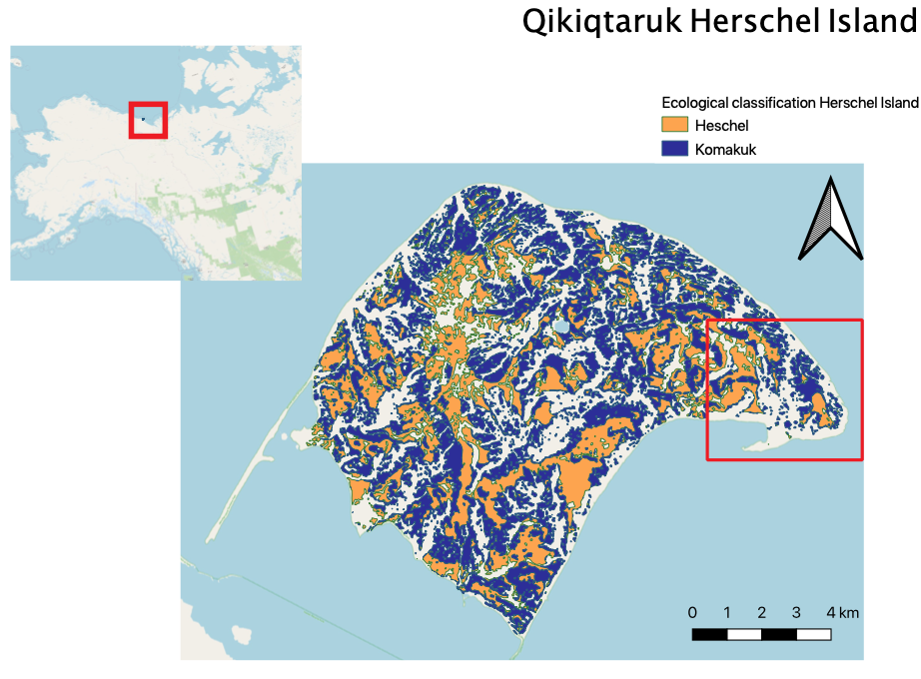

**Figure 2.1.** Extent of Herschel and Komakuk vegetation types across Qikiqtaruk-Herschel Island, with the inset map depicting the location within North America. The extent of the red square on QHI indicates the study site, Collison Head, and the location the long-term monitoring plots from were spectral measurements were taken (data source: vegetation classification (Obu et al., 2017))

QHI is floristically composed of predominantly lowland Arctic tundra plant communities, consisting of seven discrete vegetation type (Obu et al., 2017). Only the two dominate vegetation types, Herschel and Komakuk, were investigated in this study. Herschel vegetation type is characterized by relatively undisturbed moist acidic tussock tundra with an expanding willow canopy layer (Myers-Smith, Hik, et al., 2011). Komakuk is composed of herbaceous and graminoid tundra, subjected to cryoturbation and surface disturbances (Myers-Smith, Hik, et al., 2011; Myers‐Smith et al., 2019). Each vegetation has 6 established 1 m 2 plots being monitored since 1999, according to ITEX methodology and are arranged randomly along 50m transects (Molau, 1995).

* 1. **Data Acquisition**

Figure 2.2 is a workflow diagram outlining key steps in data acquisition, manipulation, analysis, and visualization.

**Insert figure**

**2.3 Plot Scale Spectral Data**

All analysis conducted relied on plot level spectral data collected over the 2018 and 2019 field season. Spectral data in both years were collected from 1x1m long-term monitory plots that exist in Herschel and Komakuk vegetation types (6 plots each). To capture within plot spatial heterogenetic, long-term monitoring plots were partitioned into 9 subplots (3x3 m grid) from which replicate measurements were taken. In 2018, each subplot was reflectance and was measured at 9 distinct points, while in 2019, spectral measurements were only duplicated at each subplot. (MAKE FIGURE for protocol). In 2019 Additional spectral measurements were taken in areas exhibiting typical Herschel or Komakuk compositional features. These were grouped as mixed, as plots were alternatively sampled and could not be assigned to their original vegetation type. Point measurements were aggregated at plot level to represent the spectral signature of each community. Spectral measurements were taken during the end of the peak season phenological phase (04th August in 2018 and 30th & July in 2019). Solar radiance conditions at the time of spectral measurements varied between the years - 2018 being overcast and 2019 being sunny. Measurements were calibrated for downwelling radiance, using a white micasense plate. Spectral measurements were taken using two different spectrometers, with 2018 data having a higher spectral resolution. The obtained reflectance values were subset to 400–985 nm, filtering sensor noise present at the spectrometer’s limits of detection range.

Add plot GPS

**xxx. airborne remotely sensed spectral**

Airborne visible/infrared imaging spectrometer AVIRIS sensor data were taken by NASA during the 2019 field season. airborne remotely sensed hyperspectral data span across Qikiqtaruk-Herschel Island at two different dates (2nd July 2019 & 27th July 2019) at spatial resolution of 5m per pixel. Using spatial extent data of vegetation types (Obu et al., 2016), 50 plots within each vegetation type could be assigned from which to extract spectral data. Due to navigation issues during data collection, airborne spectral data had unresolvable georectification issues. Therefore I was not able to continue and finish my analysis for research questions 5 and 6.

**2.4 Spectral Diversity Metric**

The coefficient of variation (CV) was used as the spectral diversity metric (Rocchini et al., 2010; Wang, Gamon, Emmerton, et al., 2016) (equation 1). CV is an expression of the spectral diversity of all the individual spectral measurements within a single plot.

**(1)**

$${CV}_{(plot) }= \frac{\sum_{λ1}^{λ2}{(\frac{ σ(ρλ)}{μ(ρλ)}})}{number of bands}$$

*ρλ is the reflectance at wavelength λ.* σ*(ρλ) and μ(ρλ) are the standard deviation and mean value of reflectance at wavelength λ across all the pixels in one plot. (Wang, Gamon, Cavender-Bares, et al., 2018b).*

**2.5 Plot Level Point Framing Data**

At each of the long-term monitoring plots, vegetation compositional, structural, and phenological properties were collected using a point-framing vegetation surveying methods. Point framing involves partitioning each plot is into 100 1cm2 cells and systematically recording species, tissue type, and statues (standing/dead). From point framing data, I calculated per plot, the biodiversity metrics richness and evenness using percentage cover of each species. Additional factors likely to influence spectral diversity where also calculated. These included bare ground, total vegetation cover, dead tissue, flowing tissue, as well as total graminoid and shrub cover. Only relevant observation of the top canopy layer where included, as sub-levels do not directly influence reflectance (Gholizadeh et al., 2018).

**Cite ITEX methodology, add point framing image**

**2.6 Spectral Band Selection**

**2.6.1 Manual Band Selection**

I conducted a manual band selection through identifying relevant spectral regions based on a literature review of other studies featuring spectral analysis of Artic vegetation (table 2.4.1). I synthesized band sections of multiple sources and adapted them based on *a priori* assumption of the predicted biological significance spectral regions. Previous work indicates that regions in the blue, green peak, red, and middle of red-edge (680-725 nm) regions of the spectrum are particularly distinct between vegetation types. (Beamish et al., 2017; Bratsch et al., 2016; Buchhorn et al., 2013; Huemmrich et al., 2013; Liu et al., 2017).

*Table 2.4.1- The wavelengths included in supervised band selection and relevant biological significance.*

|  |  |  |
| --- | --- | --- |
| Wavelength | Spectral Region | Biological significance |
| 430-450 | Blue | Chlorophyll & carotenoid absorption |
| 545-555 | Green | Green reflectance peak |
| 660-680 | Red | Max absorption of chlorophyll |
| 700-725 | Red | Middle of red-edge transition |
| 745-755 | NIR | End of red-edge transition |
| 920-985 | IR | Vascular plant structures & water absorption |

**2.6.2 Automatic Band Selection**

An additional automatic band selection for dimensional reduction was conducted. While improving classification accuracy, manual band selections do not filter spectral noise and are susceptible to removing bands that contain important information for vegetation type discrimination (Gholizadeh et al., 2018). Therefore, I used Stabile Zone Unmixing (SZU) to automatically select a subset of bands. SZU, is a type of spectral mixture analysis that aims to provide robust and automated band selections to yield the optimal subset of bands for discriminating vegetation types. This is achieved through calculating the InStability Index (ISI) (Somers et al., 2010), a ratio index based on reflectance of each band across the entire measured spectrum and identifies bands (Equation1). The ISI helps identify bands that are least sensitive to spectral variance, while maintaining comparably higher intertype differentiation.

**(1)**

$${ISI}_{i}= \frac{1.96(σ_{1,i}+σ_{2,i})}{{| R}_{mean,1,i}-R_{mean,2,i} | }$$

*Rmean,1,i and Rmean,2,i are the mean reflectance values of each vegetation type and σmean,1,i and σmean,2,i are the standard deviations of the reflectance values (Somers et al., 2010).*

ISI values represent the intra-community spectral variance when compared to inter-community differences. A lower ISI indicates that a band is better at discriminating vegetation types (Beamish et al., 2017). Comparing ISI values across the entire spectrum, identifies the spectral regions best suited to discriminating Artic vegetation types. Furthermore, specific wavelengths and the associated biophysical features can be identified (Beamish et al., 2017). This helps explain the origin spectral differences between vegetation types.

The computed ISI values were used as a selection criterion for the final band selection. A three-band moving window was used to identify and select local ISI minima. Local minima selection enables the automated and flexible selection of bands across the entire spectrum and does not exclude bands from variable spectral regions (Beamish et al., 2017). I conducted an additional post hoc automated band selection exclusively using 2019 measurements, as these had more distinct endmembers, cited to be essential to providing accurate and appropriate band selections (Somers et al., 2010; Song, 2005). This helped assess the robustness of the automated band selection. The theoretical optimum number of bands to discriminate bands was found by calculating DISI,  the amplitude at which estimated accuracy decreaseswith the inclusion of each additional bands (Full methods; appendix xxx)

**2.7 Statistical Analysis**

I conducted my statistical analysis using R (v.3.6.2). No hierarchical structure existed, as spectral mean and diversity are aggregated on a plot level. Therefore, I used a multiple linear regression model (MLRM) to conduct my statistical analysis.

Normality and homoscedasticity were assed using Q-Q plots. To test how vegetation types influence spectral signatures, separate multiple linear regression models were used for spectral mean and spectral diversity. The same models were used to evaluate H2c, with spectral diversity calculated using the subset of bands that were selected in manual and automatic band selections.

*Spectral mean ~ vegetation type + year*

*Spectral diversity (CV) ~ vegetation type + year*

The following multiple linear regression model was used to quantify how species richness, evenness and bare ground affect spectral diversity. Interaction factors were included between vegetation type and each continuous variable.

*Spectral diversity (CV) ~ vegetation type + year +*

*(vegetation type \*richness) +*

*(vegetation type \*evenness) +*

*(vegetation type \*bare ground)*

Variables in linear models where considered to be significant at p-value with an alpha level of 0.05 and if standard error around

1. **Results**

**3.1 How do Arctic Vegetation types discriminate based on the mean reflectance and spectral diversity of hyperspectral signatures?**

**Mean reflectance**

Coefficients:

Estimate Std. Error t value Pr(>|t|)

Type HE 0.17610 0.02522 6.984 5.21e-07 \*\*\*

Type KO 0.25466 0.02522 10.099 1.01e-09 \*\*\*

Type mix 0.30375 0.04375 6.942 5.71e-07 \*\*\*

year2019 0.07209 0.03074 2.345 0.0285 \*

**Estimate Std. Error t value Pr(>|t|)**

**(Intercept) 0 .12790 0.01963 6.514 1.49e-06 \*\*\***

**typeKO -0.07855 0.02372 -3.312 0.00317 \*\***

**typemixed -0.07560 0.03202 -2.361 0.02749 \***

**year2019 0.16082 0.02394 6.718 9.42e-07 \*\*\***

**3.1.1 Spectral signatures by vegetation type**

Mixed veg?

When comparing Vegetation types, Herschel plots had lower mean reflectance and higher spectral diversity than Komakuk plots. MLRM predicted that Herschel vegetation had a lower mean reflectance than Komakuk (estimate HE=0.18; estimate Herschel=0.25)(p=0.02, SE=0.03, n=26)(appendix). Herschel type had a higher spectral diversity than Komakuk type (estimate HE=0.13; estimate KO=0.05) (p=0.02, SE=0.02, n=26). Mixed

There is evidence that vegetation types can be identified based on their mean reflectance and spectral diversity, implying an acceptance of H1a. and H1b.. Vegetation had greater predicted differences based on their spectral mean, implying a rejection of H1c.

****

**Figure 3.1.1 Panel plot comparing mean reflectance and spectral diversity (CV).** Panel A and B: The mean reflectance and spectral diversity between different vegetation types. Red and Green points correspond with measurements from 2018 and 2019 respectively. C and D: Mean reflectance and spectral diversity across the spectrum of each vegetation types in each year. Background colors correspond to each region of the spectrum; blue 400-500 nm, green 500-600 nm, red 600-680 nm, near infra-red 680-800, infra-red 800-985.

**3.1.2 Spectral Signatures by year**

Predicted mean reflectance and spectral diversity values where greater in 2019 measurements, mean reflectance (estimate=0.07) (p=0.03, SE=0.03, n=26) spectral diversity (estimate=0.16) (p<0.001, SE=0.2, n=26) (appendix). When comparing between years, vegetation types had reversed trends in terms of mean reflectance, Herschel have a higher mean reflectance than Komakuk in 2018 and lower mean reflectance in 2019.

**3.1.3 When ordinated do spectral signatures discriminate among vegetation type and year**

The spectral discrimination of vegetations types in an ordination approach was only possible for 2019 measurements. Here, Herschel and Komakuk had a sufficiently large distance in spectral feature space and greater inter-group differentiation than intra-group variation. When ordinated, spectral signatures clustered primarily by year (along the PC1 axis) with 2018 Heschel and Komakuk groups overlapping. Mixed vegetation spectral signatures did not discriminate into two groups corresponding with 2019 Herschel and Komakuk measurements, despite being selected based on exhibiting distinct compositional characteristics of either vegetation type.



**Figure 3.1.2 PCA of spectral signatures grouped by vegetation type and year.** Spectral signatures of each plot were arranged in ordinal space according to mean reflectance and spectral diversity. Large points indicate the center of each group. PC1 accounted for 54.7% of variance and PC2 46.3%

Spectral signatures were also ordinated separately by year (appendix xxx). General trends remained relatively consistent, with 2019 measurements showing less differentiation.

**2: Does band selection influence correspondence between spectral diversity and vegetation types?**

**3.2.1 What regions of the spectrum best discriminate vegetation types?**

I identified the red region of the spectrum to best discriminate vegetation types, based on mean ISI (table 3.2.1). This implies acceptance of H3a, where visible regions of the spectrum were predicted to have higher correspondence with vegetation type. Despite having relatively small inter-type difference in mean reflectance, single bands the that green-red transition had the lowest ISI values and were the most informative for discriminating vegetation types (figure 3.2.1). The two selected bands with the lowest ISI values, 573 and 599 nm correspond with anthocyanin absorption (Beamish et al., 2017; Merzlyak et al., 2008). The red-edge transition (~690 - 740 nm) had relative peak in ISI values at 718 nm, which corresponds with the point of transition from chlorophyll adsorption to canopy structure scattering (Asner and Heidebrecht, 2002; Daughtry, 2000). The NIR region exhibited a plateau with relatively low and consistently stable ISI values from 750-800 nm. The Blue and IR regions respectively were the least discriminative, as well as the most variable, despite sensor noise at the limits of the spectrometer detection range being removed. The additional band selection using more spectrally distinct endmembers in the 2019 data (**appendix** xxx), had visual correspondence with the full band selection using 2018 and 2019 data.

**Table 3.2.1** Summary of ISI values by region, and breakdown bands selected. A lower ISI indicates that a band is better at discriminating vegetation types

|  |  |  |  |  |
| --- | --- | --- | --- | --- |
| Region | Total ISI | Mean ISI | Number of bands selected |  |
| Blue | 1161 | 19 | 5 |  |
| Green | 1044 | 17.1 | 2 |  |
| Red | 799 | 16 | 3 |  |
| NIR | 1326 | 17 | 3 |  |
| IR | 2218 | 18.2 | 11 |  |



**Figure 3.2.1 InStability Index (ISI) of bands across the spectrum.** ISI values indicate how well bands discriminating vegetation types, with low values being more discriminative. Clear dots along the plotted ISI and the corresponding rugs indicate bands selected, via local minima selection. Background colors correspond to each region of the spectrum; blue 400-500 nm, green 500-600 nm, red 600-680 nm, near infra-red 680-800, infra-red 800-985.

**3.2.1 What bands were selected following automated band selection?**

Automatic band selection yielded a dimensionally reduced, but spectrally diverse subset of bands, indicating an acceptance of H3b. Yet, there was a proportionally high inclusion bands IR and blue regions. The applied three-wavelength moving window for minima selection unequal distribution of selected bands, due to regionally differences ISI variability.

Plotting cumulative D­ISI, I value show the amplitude at which estimate accuracy deceases with the inclusion of each additional bands (figure 3.2.2). I found a global maximum at 3 selected bands, which indicates the theoretical optimum number of bands. Each further additional band included provides less information relative to introduced variability and reduces the spectral discrimination of vegetation types (Somers et al., 2010). The moving window minima selection selected 25 bands



**Figure 3.2.2 D­ISI, I Accumulation by number of bands selected.** D­ISI, I is the amplitude at which estimate accuracy deceases with the inclusion of each additional band. The red dashed line indicates the global maximum at selected bands. This is the theoretical optimum number of selected bands to best discriminate Herschel and Komakuk vegetation types based on their spectral signatures. The dotted black line at 25 indicates the number of bands selected using the three-band moving window minima selection. (full methods; appendix xxx)

**3.2.2 Does band selection result in greater discrimination between vegetation types based on spectral signatures?**

I found that band section in not result in greater differentiation between vegetation types based on their spectral signatures, implying a rejection of H2a. Manual and automatic selection included 24 and 25 bands respectively.

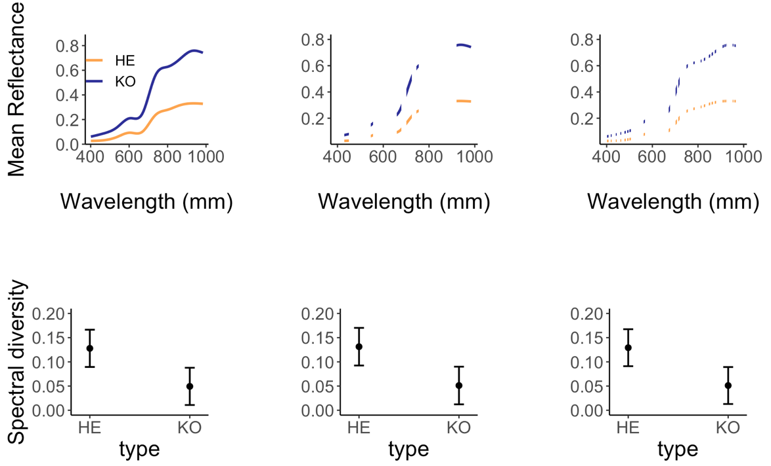

**Figure 3.2.2 Comparison of predicted mean reflectance and spectral diversity.** The first row (A,B,C) is a visual representation of the bands selected to used in model. Each column corresponds with one set of bands, with (A,D) being the full spectrum, (B,E) manual band selection, and (C,F) automated band selection.

**3.3 How does spectral diversity relate to species richness, evenness, and bare ground?**

**3.4.1 How does spectral diversity relate to richness and evenness?**

Spectral diversity did not have a consistently significant positive correspondence with either species richness or species evenness implying a rejection of H3b andH3c (figure 3.4.1, appendix). Only species richness in Herschel vegetation had a significant relationship with Spectral diversity (estimate=0.05, SE=0.02, p-value=0.02, n=11).

**3.4.2 How does bare ground relate to biodiversity?**

I did found relationship between spectral diversity soil- background in either vegetation types (figure 3.4.1, appendix). This implies a rejection of H2d and H2e which predicted a strong positive correspondence between bare ground and spectral diversity. Increased bare ground did tend to result in lower spectral diversity, but large errors were associated with predicted values. .

**Change to Nrow2!!!!!!!**



**Figure 3.4.1 Multiple linear regression models predicting spectral diversity (CV).** Spectral diversity **(**A) increases with richness in Herschel vegetation, (B) does significantly correspond with eveness (C) trends to decrease at higher soil background. Herschel vegetation types estimates are in yellow and Komakuk blue, with ribbon representing the upper and lower bounds of the 95% confidence intervals. Plotted points represent computed spectral diversity estimates. Herschel type, n=11, Komakuk type, n=10)

**3.4.3 How is spectral diversity influenced by additional environmental factors?**

When spectral signatures were ordinated with additional environmental factors derived from point framing data, total cover had close positive correspondence with spectral diversity (CV). Total cover incorporates both canopy and sub-canopy vegetation layers and indicates greater vegetation density. Aside from the previously tested factor bare ground, flowering tissue was directionally opposed to spectral diversity.

****

**Figure 3.4.4 Ordination of spectral diversity (CV) and environmental factors.** Groups were colored with red indicating Herschel 2018, yellow Herschel 2019, purple Komakuk 2018, blue Komakuk 2019. Factors where colored by type, green being diversity indices, orange environmental factors, and lavender spectral properties. **Dead, graminoid, shrub, and reproductive tissue represent plot cover at canopy layer (visible when looking from above)**. Mean reflectance is denoted as Spec\_mean; spectral diversity as CV. PC1 accounted for 38% of variance and PC2 25%.

**3.4 Are closer measurements more similar than more distant measurements?**

All spectral measurements within one vegetation type exhibited degrees of spatial autocorrelation. The distance to the sill indicated uncorrelation of measurements 20 meters (figure 3.4). Plots of each vegetation type were arranged along transect, with a maximum distance of 50 m between the first and last plot, meaning some spatial autocorrelation is always present. **The nugget to sill ratio indicates what percent of the total observed variance is observed at distances smaller that minimal distance between two plots. With nugget to sill ratio of 70% percent of variance between measurements can be attributed to distance (cite).**

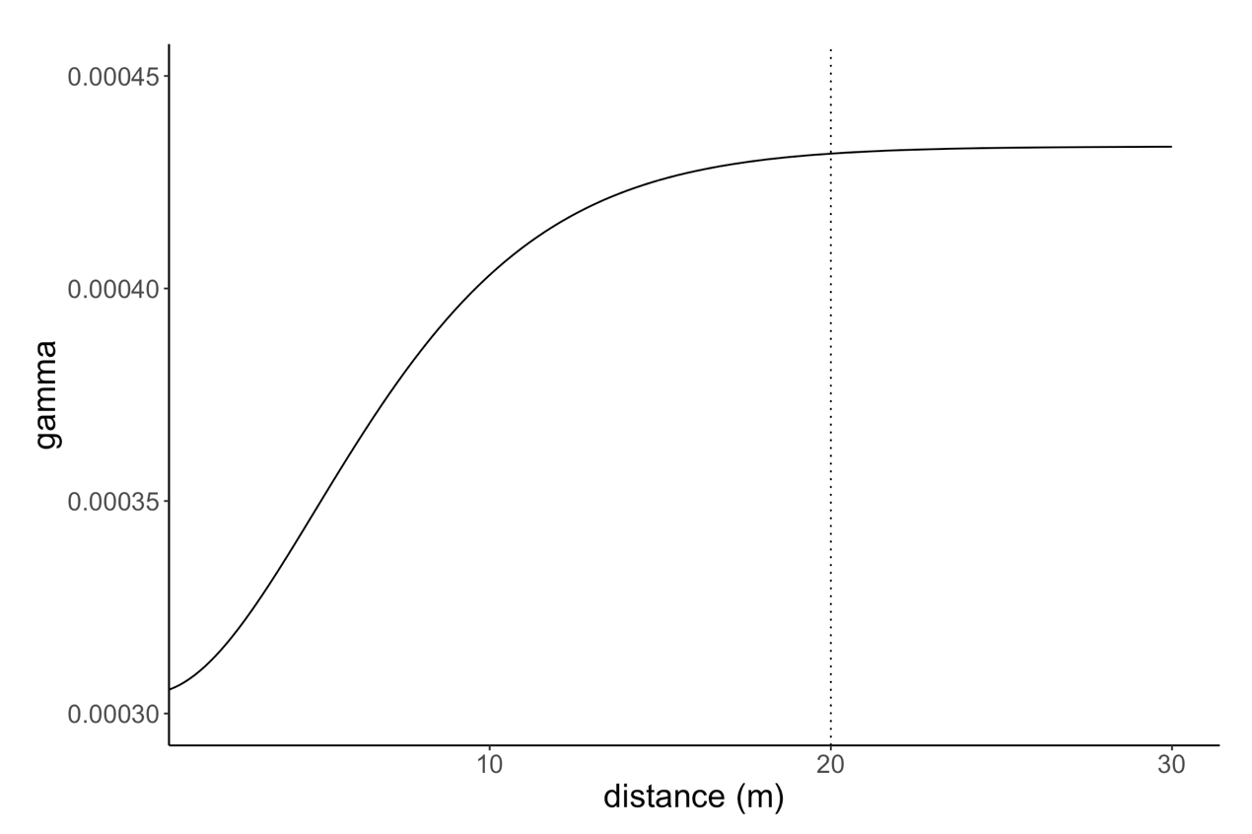

**Figure 3.4 Variogram of spectral measurements.** Nugget at 0.00031; sill at 0.00043

**4. Discussion**

**4.1 Key findings**

I found that dominate vegetation communities do have distinct spectral signatures which they can be identified by, but that mean reflectance was a better predicator of vegetation than spectral diversity, suggesting an acceptance of H1a-H1b, and a rejection of H1c. In an ordination approach vegetation types discriminated year and only partially by vegetation type, resulting in a rejection of H1d and acceptance of H1e.

Spectral zone unmixing showed that overall bands from the green-red transition regions (570-670 nm) of the visible spectrum are the most distinct between vegetation types, resulting in an acceptance of H2a. Dimensional reduction, through automated band selection provided a small but spectrally diverse subset of bands, accepting H2b. Both manual and automatic band selections did not visually improved discriminating vegetation types based other their spectral signatures, resulting in an rejection of H3a. Spectral diversity did not have a consistent positive relationship with species richness, species evenness and bare ground, and a rejection of H3b – H3e.

My results show that the applicability of using spectral signatures for the identification of Arctic tundra vegetation communities and correspond with other relevant literature in both tundra and non-tundra biomes. Yet, the incongruence in observed my results and previous literature highlights the challenges of using hyperspectral data for biodiversity predications.

**4.2 How do Arctic Vegetation types be discriminate based on the mean and variance of hyperspectral signatures?**

**4.2.1 Spectral signatures by vegetation type**

My results indicate vegetation types show greater discrimination based on their mean reflectance. I anticipated that spectral diversity would have larger correspondence with vegetation types, as spectral diversity can account for complexity of reflectance patterns across the spectrum (Wang, et al., 2016; 2018). Herschel and Komakuk vegetation types did significantly differ in their spectral diversity, but mean reflectance had a stronger relationship with vegetation type. This may be explained by between vegetation type differences in reflectance being most pronounced in the NIR and IR region of the spectrum.

This may be a result of the relative dominance of shrubs Herschel and graminoids Komakuk vegetation types (Myers-Smith, Hik, et al., 2011). Graminoid vegetation having greater canopy complexity, would result in higher reflectance in the IR region (Cavender‐Bares et al., 2017). Higher IR reflectance in Komakuk vegetation resulted in vegetation showering greater differentiation by mean reflectance.

Phenological phase may influence how vegetation type discriminate, based on mean reflectance and spectral diversity. Measurements were taken during the maximum canopy, when vegetation tissue density and structure is most pronounced (Bratsch et al., 2016). Increased canopy and vegetation density predominantly amplify reflectance in the NIR and IR regions of the spectrum (Asner and Martin, 2009; Ollinger, 2011). Differences in reflectance would be expressed in mean reflectance values but are not necessarily captured by spectral diversity.

Vegetation types may show greater discrimination by spectral diversity during senescence. (add brayant scentence?) At vegetation senescence, differences in chemical properties, such as photosynthetic pigmentation are most prominent (Beamish et al., 2017). Photosynthetic pigmentation influences reflectance across multiple spectral regions, resulting in vegetation types showing less differentiation based on their mean reflectance (Wang, et al., 2018; 2018b). Spectral diversity accounts for variation across spectral regions and would be a better metric for distinguishing vegetation types (ibid). Quantifying how mean reflectance and spectral diversity vary between phenological phases, could provide insight into when vegetation types are most distinct in their spectral signatures.

Furthermore, at senescence, environmental factors such as flower cover are less pronounced. I found that flower negatively correlated with spectral diversity and which have reduced as seen in Heumann et al., 2015.

NDVI also appeared to be affected by flowering, with the mid-season NDVI dip coincident with the period of anthesis (flower opening) for many of the dominant species (**[Figure 5](https://www.mdpi.com/2072-4292/8/2/128/htm" \l "fig_body_display_remotesensing-08-00128-f005)**c).

the time of maximum flower opening, which has also been shown to reduce NDVI depending upon flower color and its influence on the reflectance spectrum [**[34](https://www.mdpi.com/2072-4292/8/2/128/htm" \l "B34-remotesensing-08-00128" \o ")**,**[35](https://www.mdpi.com/2072-4292/8/2/128/htm" \l "B35-remotesensing-08-00128" \o ")**,**[36](https://www.mdpi.com/2072-4292/8/2/128/htm" \l "B36-remotesensing-08-00128" \o ")**].

although the exact reasons for this deserve further study. This dynamic relationship was most likely affected by canopy development, as well as by prevailing conditions (mid-season warm, dry conditions) and flowering phenology (timing of anthesis).

In reviewing knowledge about the factors affecting canopy reflectance, several interesting themes have emerged. In attempts to identify specific drivers of reflectance, uncer- tainties related to scattering presently outweigh uncertain- ties related to absorbers (pigments, water, etc.). This is perhaps because absorbers influence specific spectral regions and can be measured more easily than structural properties. Factors such as leaf anatomy and leaf angle distribution affect scattering over all wavelengths in ways that are diffi- cult to quantify. This presents a challenge for understanding reflectance in the NIR region, where multiple combinations of interdependent properties can yield similar patterns of reflectance. This does not necessarily restrict our ability to

Unlike pigmentation with specific absorbance regions, leaf structure and canopy complexity scatters light across wavelengths (Ollinger, 2011).

**4.2.2 Spectral signatures by year**

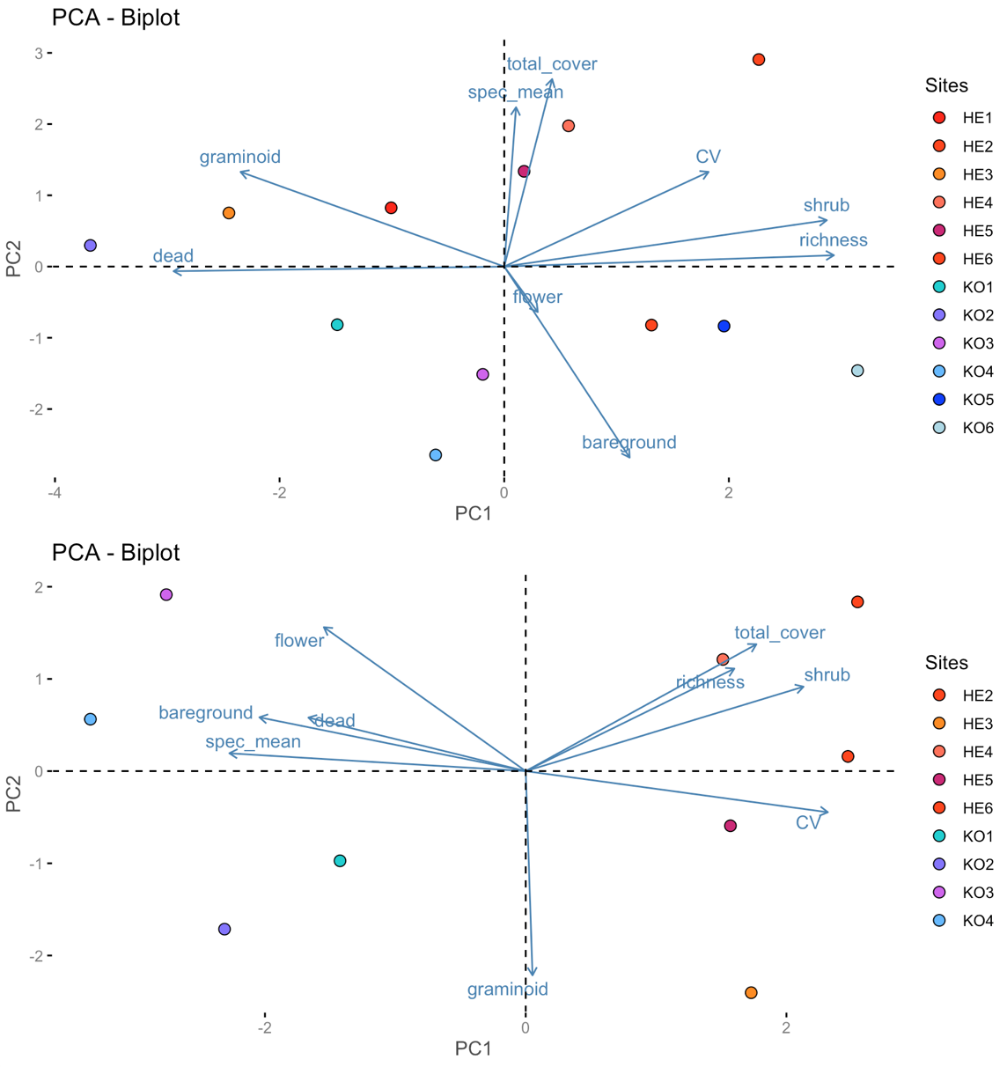

Between year variation in spectral signatures may be attributed to inconsistencies in weather conditions. At Arctic sites, persistent cloud cover, variable solar irradiance, and short phenological phases impact measurement quality and the ability to replicate measurements between years (Beamish et al., 2017). Increased cloud cover during 2018 measurements likely confounded spectral data, resulting in less spectral differentiation between vegetation types in 2018 (Hope et al., 1993). While measurements where calibrated for solar irradiance conditions, this only standardizes reflectance.

**cs**

Phenology at time of measurements may have resulted in the observed differences in mean reflectance between years. Short growing seasons at high latitudes result in rapid sifts in phenology (Bjorkman et al., 2015). Measurements occurring 6 days earlier in 2019 could result in vegetation still exhibiting typical maximum canopy characteristics, while in 2018 vegetation would be beginning to senescence. Pigmentation concentration, and canopy density decrease during senescence, resulting in lower mean reflectance (Chavana-Bryant et al., 2017; Wang, et al., 2016b). Lower mean reflectance of both vegetation types in 2018 relative to 2019, may be attributed to measurements occurring at during early senescence.

Exploratory analysis indicated that wetness in unlikely to have influences spectral signatures between years. Wetness increases absorbance in the red and NIR regions of the spectrum, resulting in a lower mean reflectance (Buchhorn et al., 2013; Liu et al., 2017). Using point framing data, I identified two plots, which had records of standing water, indicating higher wetness. When ranked I observed no visual trend of wetness influencing spectral signatures, as wet plots in 2018 had both the highest and lowest mean reflectance. Furthermore, between years the wet plots did not have consistently low mean reflectance values. Therefore, seasonal weather variation influencing wetness do not explain the spectral difference in between years.

Deviations in levels of replication may have contributed to differences in spectral signatures. Reduced replication in 2019, could have resulted in obtaining an unrepresentative sample including greater small-scale heterogenic features. Factors such as stones, and lichens can increase reflectance in the NIR and IR regions (Asner, 1998; Chuvieco et al., 2002). Komakuk plots have increased bare ground visibility and an increased chance of including high reflectance heterogenic features. Yet a post hoc MLRM found that bare ground has a non-significant slightly negative relationship with spectral mean (appendix xxx). Unrepresentative sampling of small-scale heterogenic features is likely not connected variability in spectral signatures.

Sensor type

The divergence of spectral signatures between years, and multiple potential error sources highlights the challenges of using spectral data in artic sites.

To see what environmental factors influenced mean reflectance and spectral diversity, I ordinated 2018 and 2019 data separately. I found shrub cover and environmental factors that consistent corresponded with mean reflectance or spectral diversity in both years. This indicates that no en

Unlikely and unsubstantiated, but Artic is rapidly changing and between year change may have contributed to differences in spectral signatures. for example in 2019 there was 1.8x less visable soil and flowers, while 1.6x more visbale dead structures.

Lichen cover increases reflectance in ultraviolet

**4.2.3 Identifying vegetation by spectral signatures in ordination**

I found that when ordinated only spectral signatures from 2019 Herschel and Komakuk plots visually discriminated. The lack of inter-type differentiation between 2018 plots, and strong intra-type differences between 2018 and 2019 suggests uncertainty in how well spectral signatures can be used to identify vegetation types.

When ordinate, I expected that mixed plots would split into two groups, each corresponding with one vegetation type. Mixed plots where selected based on visually exhibiting characteristic Herschel or Komakuk features. I found that overlap between Komakuk plots occurred, but that mixed Herschel plots occupied their own region in ordinal space. This is possibly due to the mixed Herschel plots mixed plots having regional heterogeneity in vegetation compositional structure or phenotypic appearance (Asner, 1998). Alternatively, environmental factors may have had greater influence on spectral signatures than vegetation type. In an exploratory ordination I found bare ground and dead cover corresponded with increased mean reflectance (appendix). This suggests that at regional scales additional sources of heterogeneity may reduce spectral signatures distinctness, making vegetation types more challenging to discriminate. Using ordination approaches, discrimination of vegetation are dependent on both temporal and spatial factors.

**4.3 Does band selection influence correspondence between spectral diversity and vegetation?**

**4.3.1 What regions of the spectrum best discriminate vegetation types?**

I found that bands in the green-red transition region (570-670 nm) were the most distinct between vegetation types. This indicates that absorption of light caused by pigmentation are more distinct between vegetation types, than canopy complexity and structure. The single band 573 nm was the most distinct between types and corresponds with the absorbance of anthocyanin (Merzlyak et al., 2008). Leaf anthocyanin accumulation occurs as a response to temperature and light stress or vegetation entering senescence (Landi et al., 2015; Ollinger, 2011). Yet, there is no indication of either of these events in Herschel vegetation, where anthocyanin absorbance is greater. The high distinctness in this region can likely be attributed to baseline differences in pigmentation concentration between vegetation types.

spectral signatures are influenced by temporal variations in specific pigmentation concentrations at time of measurements, a trend observed in **(Chavana-Bryant et al., 2017)**

For example, leaf aging and se- nescence can cause high variation within individual tree canopies on par with the variation detected among different individuals of the same species or of that detected between species in leaf morphological, bio- chemical and spectral traits of tropical tree species (Chavana-Bryant et al., 2017).

CS

Relatively low and stable ISI values in the NIR, suggests that vegetation types have consistent differences in canopy structure and vegetation density. It is anticipated this is a result of the relative dominance of shrubs Herschel and graminoids Komakuk vegetation types (Myers-Smith, Hik, et al., 2011). Graminoid vegetation having greater canopy complexity, would result in higher reflectance in the NIR region and the observed stable spectral differences between vegetation types (Cavender‐Bares et al., 2017)(section 4.2.1)

While the visible spectrum was seen to be most important the stability of the NIR shows the advantage of going hyperspectral when attempting to differentiate vegetation types. Ollinger describes that hyperspectral regions while more variable, can add important (sometimes even the most important) information to the discrimination of vegetation types particualy in remote sensing contexts.

bands are outside of the range covered by NDVI methods for vegetation discrimination (Bratsch et al., 2016), and highlight some of the additional information afforded by using hyperspatial data. The stability of this region possibly due to differences in graminoid cover between vegetation types. Greater graminoid cover which Increases canopy structure/ complexity, which alters light interaction patterns/refraction and has been shown to influence reflectance (Schweiger et al., 2017).

**4.3.2 Does band selection improve differentiation vegetation types based on spectral signature?**

Band selections did not result a greater visual discrimination of vegetation types based on spectral diversity. This suggests that bands being distinct between vegetation types based on reflectance, do not translate to greater between type differences in spectral diversity.

Band selection was insensitive to the distantness of input spectral signatures. Song, 2005 and Somers et al., 2010 highlight the importance of using distinct endmember classes when calculating ISI to subset bands by. Therefore, I conducted an additional automatic band selection using only 2019 data, that contained more distinct endmembers (appendix). Yet, I found significant visual correspondence with the original band selections. This suggests between year consistence in bands that tended to be most discriminate. Alternatively, the most discriminative 2018/2019 bands did not correspond, but ISI values may not have been sensitive to the additional noise of less distinct 2018 endmembers.

It is also possible that using spectral mixture analysis instead of MLRMs may have resulted in better differentiation

Other dimensional reduction methods in improve discrimination of vegetation types, through using convex hull areas may have been more successful

Other band selection of spectral diversity are

Other dimensional reduction of spectral data using CHA to improve discrimination via spectral diversity, are more successful than ISI approaches, as band are selected on how they directly effect spectral diversty, not general discrimination of vegetation types at each waves bands

**Despite more than two decades of research on spectral diversity metrics, dimension reduction of hyperspectral data for biodiversity mapping has rarely been applied. Our dimension reduction approach (CHA) provided better performance than other spectral diversity me- trics when applied to the airborne data, suggesting that it holds promise for distinguishing species richness levels with imaging spectrometry Further testing dimension reduction methods in dif- ferent ecosystems at various spatial, spectral, and temporal scales re- mains necessary. (Gholizadeh et al., 2018)**

We used the convex hull concept as a means for fast and objective estimation of spectral diversity through band selection.

maximize the separation between the reflectance of a given pixel in a plot and the mean reflectance of that plot. These bands are the outcome of the band selection process via CHA. If a pixel's spectrum is similar to the average spectrum of a plot or is highly correlated with it, the convex hull area will be near zero (i.e. the bands will form a straight line). The convex hull area is calculated for all m pixels in a given plot and the average CHA provides an expression of the spectral diversity for that plot (Eq. (1)). Plots with higher species richness levels are expected to have larger average CHA, representing higher deviation from the mean spectrum. This approach explores the full spectrum and does not require training data or tuning of input parameters (i.e. it is an objec- tive approach)

DISSCUSSION? Local minima selection ideally reduces discrimination of the selection of bands in veritable spectral regions and ensures the inclusion of bands across the electromagnetic spectrum (rather than just one band). Yet here, it resulted in underrepresentation of stable and highly discriminative regions of the spectrum, and inflating the total number of included bands (ideally a number close to one, while still providing decent representation of variation across the electromagnetic spectrum)

has a smaller proportion of information contribution (accuracy of model) is less than the additional variability (error) added (Somers et al., 2010). While incrasing band selection past the theoretical optimum is important, the inclusiotn of a high porpoertion of low ISI bands is not good.

Elaborate on shortcoming of selection?

No band selection methods having visual impacts on discriminating vegetation types based on their spectral diversity suggests,

(maybe) overall SZU resulted in the selection of discriminative bands that corresponded with the a piori supervised selection. Yet the use of automated selection methods that reduce bias of discriminating variable region of the spectrum resulted in the additional inclustion of bands across the spectrum, that through a InStability Index were found less discriminative. Overall this resulted in the supervised band selection providing the greatest information content for discriminating Arctic vegetation types.

**4.4 How does spectral diversity relate to species richness, evenness, and bare ground?**

**4.4.1 How do species richness and evenness relate to spectral diversity? (evidence of spectral diversity hypothesis.)**

My results did not exhibit clear relationships between spectral diversity and biodiversity. This contradicts previous work that supports the existence of the spectral diversity hypothesis (Gholizadeh et al., 2018; Schmidtlein and Fassnacht, 2017; Schweiger et al., 2018; Wang, et al., 2016a; 2018a, 2018b). It has been shown that spectral to biodiversity relationships where stronger when using indexes that incorporate both richness and evenness, such as Shannon’s or Simpson’s diversity (Wang, et al., 2016a; 2018). In Post hoc exploratory analysis, I did not find that Shannon or Simpson evidence diversity indexes had stronger relationships to spectral diversity. My results did not show consistent spectral-biodiversity relationships and did not show evidence for the spectral diversity hypothesis.

My results not supporting the previously describes spectral diversity hypothesis is unlikely to be attributed to the temporally dynamic nature of spectral-biodiversity relationships. It has been seen that other spectral-biodiversity relationships are variable over the growing season (Wang, et al., 2016b). Yet, here it was found the NVDI best predicted biodiversity during maximum canopy.

Measurements occurring at maximum canopy can in result in the underrepresentation of short-statured vegetation and decreased potential to detect biodiversity (Gholizadeh et al., 2018; Wang, et al., 2018). Thus, increases diversity in understory vegetation would be not mirrored by increases in spectral diversity. Yet this is unlikely given that Herschel vegetation has expanding canopy forming shrubs, but was able to predict richness.

and Komakuk vegetation does not form a thick canopy layer.

Wang, et al., 2016b, found that richness estimates using Normalized Difference Vegetation Index (NDVI) where variable across the growing season. It is likely that the same is true for when estimating biodiversity with spectral diversity.

As previously described in section 4.2.1 and 4.3.1, the chemical and morphological features that determine spectral signatures are variable with phenological phase. It is likely that phenology not only impacts spectral discrimination of vegetation types, but also spectral-biodiversity relationships. Furthermore, (keep order)

(although note flower increased specbio relationship) (Wang, Gamon, Montgomery, et al., 2016) found that optical-biodiversity relationships such as NVDI to richness where most pronounced during maximum canopy and with observed temporally dynamic relationships changing over the growing season, which is likely to be the case for spectral diversity to bodiverstiy aswell. It is possible that while not corresponding that peak is best, relationships may be stronger at another phenological phase.

Link canopy structure

Full spectrum? SWIR

Wang suggested seasonal patterns of biodiversity, citing maggurn, but I find this unlikely (shurin and white aswell)

**4.4.2 How does bare ground relate to spectral diversity?**

My results indicated that bare ground do not have a significant relationship with spectral diversity. This does not correspond with previously cited literature that found bare ground to be an import predictor of spectral diversity (Gholizadeh et al., 2018; Wang, et al., 2018).

Soil reflectance is spatially-temporally variable and is sensitive to moister and roughness (Jacquemoud et al., 1992). there is the potential of general correspondence between the reflectance of high carbon soil (Jacquemoud et al., 1992; Summers et al., 2011) and the spectral signatures of Herschel and Komakuk vegetation. Yet, bare ground was characterized visible cover of standing litter, mosses, and lichen. While standing litter has spectral signatures that resemble soil (van Leeuwen and Huete, 1996), moss and lichen which have distinct spectral signatures from Arctic tundra vascular plants making this less likely (Hope et al., 1993). One area of future research could be characterizing the spectral signatures of small scale heterogenous factors such as soil (at varying moister), mosses, and lichen. this may provide more definitive insight

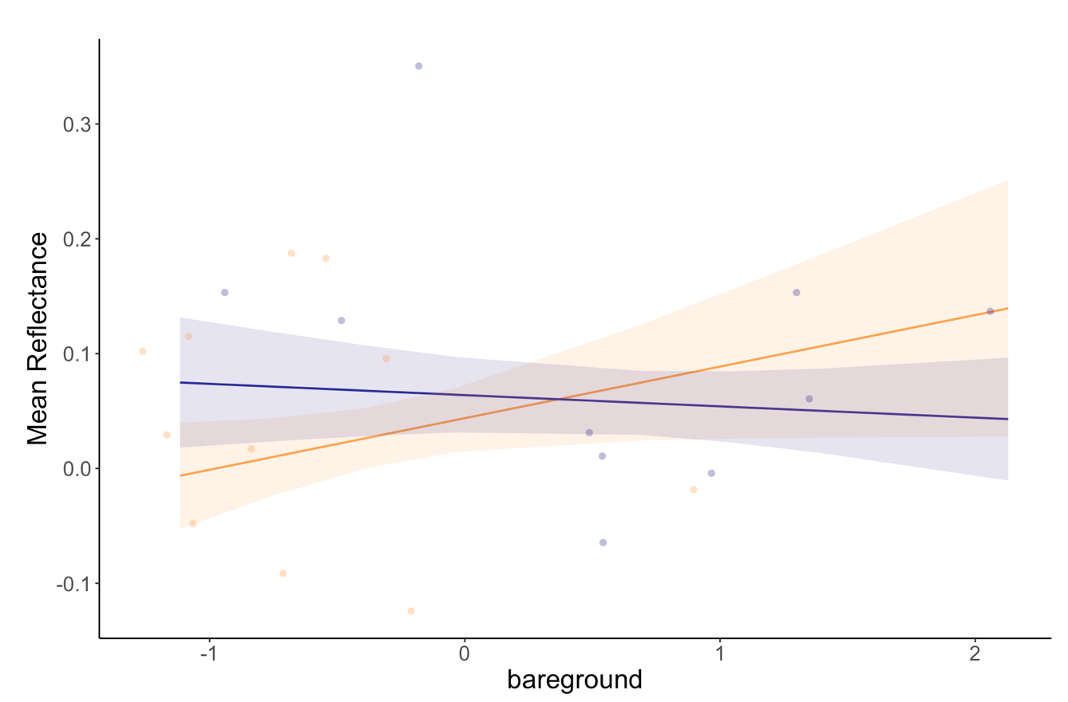

stimate Std. Error t value Pr(>|t|)

typeHE 0.04381 0.01450 3.021 0.01064 \*

typeKO 0.06390 0.01649 3.874 0.00221 \*\*

year2019 0.06842 0.01590 4.303 0.00103 \*\*

richness -0.01414 0.01181 -1.197 0.25427

evenness 0.02464 0.01698 1.451 0.17236

bareground 0.04492 0.02313 1.942 0.07595 .

typeKO:richness 0.01775 0.02668 0.665 0.51849

typeKO:evenness -0.02679 0.03031 -0.884 0.39409 .

typeKO:bareground -0.05472 0.02649 -2.066 0.06112 . Vegetation expansion is well described in across on QHI (Myers-Smith, Forbes, et al., 2011; Myers‐Smith et al., 2019), and a 55% decrease in visible bare ground was seen between years.

although it is known that soil background effects is scale depend and may first become salient at lower resolution and remotely sensed scales (Asner and Heidebrecht, 2002; Asner and Martin, 2009; Ollinger, 2011; Rocchini et al., 2010).

. Therefore, the spectra extracted from one site (or image) may not be applicable to another site and another time

Cs insignificant, and factors are favorable to remote sensing.

. The some- times-dominant presence of non-vascular components (mosses and lichens) and barren ar- eas also contribute to the unique spectral signatures of tundra landscapes (Hope et al., 1993

Potential for future research !!! keep subplot data and deserne spectral sig of small scale heterogeneous factors, van Leeuwen and Huete, (1996) have demonstrated the importance of standing litter and soil in the interpretation of biophysical parameters.

High heterogeneity in community-scale vegetation composition, soil moisture, and an abundance of litter and non-vascular components complicates interpreta- tion of NDVI and other broadband VIs in sparsely vegetated areas and outside of the peak- growing season (Liu et al., 2017). Buchhorn et al (2013) found that surface moisture re- duced reflectance in the NIR, in turn underestimating the biomass signal of low-Arctic tundra. Further, van Leeuwen and Huete, (1996) have demonstrated the importance of standing litter and soil in the interpretation of biophysical parameters. These results suggest that the small-scale heterogeneity of Arctic tundra vegetation and other internal ecosystem components are not well characterized at non-peak times, limiting our ability to gain a complete and detailed picture of vegetation change in the Arctic.

Applying spectral un-mixing to correct for soil exposure pre- sents challenges related to the “scalability” and “generality” of the spectra of endmembers (Asner and Heidebrecht, 2002; Asner and Lobell, 2000). Soil reflectance is highly sensitive to moisture and roughness (Jacquemoud et al., 1992; Pinty et al., 1998) and its re- flectance can vary within and across study sites and through time. Therefore, the spectra extracted from one site (or image) may not be applicable to another site and another time. In addition, given the findings of this experiment, removing soil background can be a limiting factor for imaging spectrometers with moderate to coarse spatial re- solutions, where the pixel size exceeds that of individual plant canopies. However, fusion of hyperspectral data with high spatial resolution multispectral data can provide the capability to extract soil background information (Yokoya et al., 2012).

Between 2010 and 2019 a 55% decrease in visible bare ground e Due to vegetation expantion on QHI,

Soil background may have decreased, a trend observseved as vegetation cover increases (Myers‐Smith et al., 2019)

one reson that spectral diveristy decreased with bare ground is the disparity between bareground and year. 2019 had 55% less bg

**remotely sensed scales.**

 Full-range (0.4-2.5 w m) sampling strategies using the most common hyperspectral or multispectral channels consistently over-estimated bare soil extent and under-estimated PV cover in our shrubland and grassland sites. This was due to bright soil reflectance relative to PV reflectance in visible, near-IR, and shortwave-IR channels. (Asner and Heidebrecht, 2002)

For discussion: one reason that richness, evenness, and soil background were seen to have weak effects is the narrow distribution of values in the data.

I predict that bare ground is the strongest predictor of spectral diversity, as soil has distinctly different reflectance than vegetation (Gholizadeh et al., 2018). Furthermore, soils reflectance is variable depending on local microclimatic conditions such as moisture and roughness. This potential for plot level variability can therefore alter spectral signatures in more complex ways, resulting in soil having the largest correspondence with spectral diversity.

**4.4.3 How do additional environmental factors relate to spectral diversity?**

Total cover includes both the top canopy and underlying vegetation and corresponds with denser and more complex vegetation cover. The close directional correspondence of spectral diversity with total canopy cover in ordinal space, indicates that light interaction increased scattering of light caused by increased canopy structures, and leaf tissue composition may increase spectral diversity

add reproductive tissue

**4.5 Are closer measurements more similar than more distant measurements?**

**4.xxx Limitations**

Keep limitaions relativley short and highlight challenges in field of hyperspectral sensing, not my sort commings -> link to table in appedex with ~five key challenges

The main limitation in my study the lack of subplot spectral data While od

Difference between years.

Could isolate which year is better and attempt to deduce.

Small-scale heterogeneity

Characterizing the spectral signatures of small scale heterogenous factors would help explain the origin of variability between spectral signatures. By linking individual spectral measurements with point framing data, the spectral signatures of factors as such as leaf litter, moss, and lichen could be determined. This would show if high reflectance measurements in 2019 Komakuk plots are explained by the inclusion of heterogeneous factors. Due to spectrometer storage issues spectral measurements could only be confidently determined at a plot scale.

Comparing of heterogeneous factor spectral signatures with those of vegetation would help evaluate the origin of spectral variation between years.

Data were recorded on a subplot level and could have been used in a hierarchical model structure. By combining subplot spectral measurement with subplot point framing data, to the primary feature in the field of view of each measurement could be obtained. This could get spectral measurements of features such as bareground, and directly include those into the model, rather than just cover.

Replication? Space?

Assessing how spectral signatures are influenced by small-scale heterogenous factors would help explain observed with type variance of spectral signatures.

. The some- times-dominant presence of non-vascular components (mosses and lichens) and barren ar- eas also contribute to the unique spectral signatures of tundra landscapes (Hope et al., 1993

Potential for future research !!! keep subplot data and deserne spectral sig of small scale heterogeneous factors, van Leeuwen and Huete, (1996) have demonstrated the importance of standing litter and soil in the interpretation of biophysical parameters.

High heterogeneity in community-scale vegetation composition, soil moisture, and an abundance of litter and non-vascular components complicates interpreta- tion of NDVI and other broadband VIs in sparsely vegetated areas and outside of the peak- growing season (Liu et al., 2017). Buchhorn et al (2013) found that surface moisture re- duced reflectance in the NIR, in turn underestimating the biomass signal of low-Arctic tundra. Further, van Leeuwen and Huete, (1996) have demonstrated the importance of standing litter and soil in the interpretation of biophysical parameters. These results suggest that the small-scale heterogeneity of Arctic tundra vegetation and other internal ecosystem components are not well characterized at non-peak times, limiting our ability to gain a complete and detailed picture of vegetation change in the Arctic.

Applying spectral un-mixing to correct for soil exposure pre- sents challenges related to the “scalability” and “generality” of the spectra of endmembers (Asner and Heidebrecht, 2002; Asner and Lobell, 2000). Soil reflectance is highly sensitive to moisture and roughness (Jacquemoud et al., 1992; Pinty et al., 1998) and its re- flectance can vary within and across study sites and through time. Therefore, the spectra extracted from one site (or image) may not be applicable to another site and another time. In addition, given the findings of this experiment, removing soil background can be a limiting factor for imaging spectrometers with moderate to coarse spatial re- solutions, where the pixel size exceeds that of individual plant canopies. However, fusion of hyperspectral data with high spatial resolution multispectral data can provide the capability to extract soil background information (Yokoya et al., 2012).

Spectral Mixture Analysis (SMA) is a technique for estimating the proportion of each pixel that is covered by a series of known cover types - in other words, it seeks to determine the likely composition of each image pixel. Pixels that contain more than one cover type are called mixed pixels. “Pure” pixels contain only one feature or class. For example, a mixed pixel might contain vegetation, bare ground, and soil crust. A pure pixel would contain only one feature, such as vegetation. Mixed pixels can cause problems in traditional image classifications (e.g., [supervised](https://wiki.landscapetoolbox.org/doku.php/remote_sensing_methods:supervised_classification" \o "remote_sensing_methods:supervised_classification) or [unsupervised classification](https://wiki.landscapetoolbox.org/doku.php/remote_sensing_methods:unsupervised_classification" \o "remote_sensing_methods:unsupervised_classification)) because the pixel belongs to more than one class but can be assigned to only a single class. One way to address the problem of mixed pixels is to use SMA, (sometimes called subpixel analysis), and hyperspectral imagery.

Spectral mixture analysis (SMA) determines the component parts of mixed pixels by predicting the proportion of a pixel that belongs to a particular class or feature based on the spectral characteristics of its endmembers. It converts radiance to fractions of spectral endmembers that correspond to features on the ground.

The use of spectral mixture analysis may have improved differentiating vegetation types based on their spectral signatures. In spectral mixture analysis vegetation type is predicted by comparing the proportion correspondence of plot level spectral signatures to those of endmembers. Furthermore, Spectral mixture analysis has been shown to further be improved through dimensional reduction, based ISI band selection (Somers et al., 2010).

The use of MLRMs to assess if manual and automatic band selection improved discriminating vegetation types based on spectral signatures may have

The use of bands in the short wave infrared regions of the spectrum (1000-2500 nm), may have improved discriminating vegetation types based on their spectral signatures (Wang, Gamon, Schweiger, et al., 2018).

When all spectra were included, higher classification accuracy and Kappa statistic values were achieved with leaf-level measurements than with image-derived measurements (Table 4). This was presumably a consequence of the image-derived spectra capturing more within-spe- cies variation than leaf-level spectra and thus overestimating the plot- level vegetation diversity. Most classification errors occurred among graminoid species (Poa pratensis, Andropogon gerardi and Panicum vir- gatum). For the leaf-level reflectance, using full range spectra increased the classification accuracy (Table 4), indicating that including in- formation in the SWIR wavelengths increased the species separability.

Add NIR stuff?

**Add year stuff!!!**

**4.xxx Future work**

Taking measurements over multiple phenological would likely improve how spectral signatures discriminate vegetation types and predict biodiversity. Pervious work has shown that spectral-biodiversity relationships are influenced by phenology (Wang, Gamon, Montgomery, et al., 2016). Yet, to date no work has been to assess how spectral diversity over time. Changes in pigmentation, leaf structure, and vegetation density influence spectral signatures. Although Arctic tundra vegetation does not from closed canopies, the prostrate shrub expansion may limit visible of sub canopy vegetation (Myers-Smith, Forbes, et al., 2011). Therefore, subcanopy spectral signatures, would not be captured. At leaf-out or senescence, reduced foliage would increase visibility, possibley increasing spectral-biodiversity relationships.

In sections xxx I predicted that phenology influenced how well vegetation types discriminate based on spectral signatures. This is supported by Beamish et al., 2017, where senescence was identified when Arctic vegetation types are most spectrally most distinct. Spectral to biodiversity relationships have been found to be temporally dynamic (wang), but to date no work quantifs how spectral diversity changes over time.

To date no work has been conducted to assess how spectral diversity changes over time. Assessing the

I found that the most distinct spectral region between vegetaion types xxx nm, closly corresponded with anethenocyian, a pigment that is temporally dynamic in its concentration. Other pigments and structures are variable over time and are also likely to have an effect chvana 2017

As indicated in sections xxx,xxx,xxx, I predict that phenology by influencing chemical and morphological characteristics may influence vegetations spectral signatures, impacting how vegetation types spectrally discriminate, as well as spectral-biodiversity relationships.

To address how phenology influences spectral signatures, significant insight may be afforded, by taking spectral measurements across the growing season. Beamish et al., 2017, identified the at senescence Arctic vegetation types are most spectrally most distinct.

The influence of phenology on

WhileWang et al, 2016b assessed how NDVI to biodiversity relationships change over growing season, to date there has been no work the same for spectral diversity. By assessing how spectral signatures and spectral diversity changes across phenological phases, key physiogical drives differences in spectral signatures may be identified and drives temporally dynamic spectral-biodiversity relationship

Including vegetation phenology has been shown to increase spectral discrimination of vegetation types (Clark and Roberts, 2012), (and could improve the imformation to improve spectral diversity hypothesis.

Leaf aging and chemical change has been shown to cause high variation within individual For example, leaf aging and se- nescence can cause high variation within individual tree canopies on par with the variation detected among different individuals of the same species or of that detected between species in leaf morphological, bio- chemical and spectral traits of tropical tree species (Chavana-Bryant et al., 2017) The identification of anthenocyian as being important highlgihts this. In general leaf

Alison beamish 2017 has demonstrated that the senscene phase is when Arctic vegetation types differ most spectraly. Given similar chemical and morhogical characteristics, (and correspondce between manual and automatic band selection) this might be the case here. While wang did NDVI of growing season no such work has been done with spectral diversity.

My predicitions that mean reflectance is greatest at peak (due to higher NIR matter) and spectral diversity at senescence (more pigment)

Temporally dynamic spectral-biodiveristy relationship

although the exact reasons for this deserve further study. This dynamic relationship was most likely affected by canopy development, as well as by prevailing conditions (mid-season warm, dry conditions) and flowering phenology (timing of anthesis).

Mean reflectance being a stronger predictor of vegetation type may be explained by between types differences in reflectance being concentrated in only one region of the spectrum. Measurements were taken during the maximum canopy phenological phase, when vegetation tissue density and structure is most pronounced (Bratsch et al., 2016). Increased canopy and vegetation density predominantly amplify reflectance in the NIR and IR regions of the spectrum (Asner and Martin, 2009; Ollinger, 2011). These differences in reflectance would be expressed in mean reflectance values but are not necessarily captured by spectral diversity.

Phenological phase may influence how vegetation type discriminate, based on mean reflectance and spectral diversity. At vegetation senescence, differences in chemical properties, such as photosynthetic pigmentation are most prominent (Beamish et al., 2017). Photosynthetic pigmentation influences reflectance across multiple spectral regions, resulting in vegetation types showing less differentiation based on their mean reflectance (Wang, et al., 2018; 2018b). Spectral diversity accounts for variation across spectral regions and would be the better metric for distinguishing vegetation types (ibid). Quantifying how mean reflectance and spectral diversity vary between phenological phases, could provide insight into when vegetation types are most distinct in their spectral signatures.

Furthermore, at senescence, environmental factors such as flower cover are less pronounced. I found that flower negatively correlated with spectral diversity and which have reduced as seen in Heumann et al., 2015.

NDVI also appeared to be affected by flowering, with the mid-season NDVI dip coincident with the period of anthesis (flower opening) for many of the dominant species (**[Figure 5](https://www.mdpi.com/2072-4292/8/2/128/htm" \l "fig_body_display_remotesensing-08-00128-f005)**c).

the time of maximum flower opening, which has also been shown to reduce NDVI depending upon flower color and its influence on the reflectance spectrum [**[34](https://www.mdpi.com/2072-4292/8/2/128/htm" \l "B34-remotesensing-08-00128" \o ")**,**[35](https://www.mdpi.com/2072-4292/8/2/128/htm" \l "B35-remotesensing-08-00128" \o ")**,**[36](https://www.mdpi.com/2072-4292/8/2/128/htm" \l "B36-remotesensing-08-00128" \o ")**].

although the exact reasons for this deserve further study. This dynamic relationship was most likely affected by canopy development, as well as by prevailing conditions (mid-season warm, dry conditions) and flowering phenology (timing of anthesis).

(Landi et al., 2015; Ollinger, 2011). This indicates that Herschel vegetation, (that has higher absorption at 573 nm and thus higher anthocyanin concentraion) may be i) experiencing greater levels of environmental stress and may be more susceptible to future Arctic warming and ii) that Herschel enters senescence earlier than Komakuk vegetation. Furthermore, anthocyanin concentration being temporally variable supports 4.2.1, that phenological phase influences spectral signatures and how vegetation types differ based on their spectral signatures. (split in two)

Anthocyanin being an important to differentiation vegetation types, supports 4.2.1 that phenological phase are important and highlights that spectral signatures are influenced by temporal variations in specific pigmentation concentrations at time of measurements, a trend observed in **(Chavana-Bryant et al., 2017)**

My results not supporting the previously describes spectral diversity hypothesis may be attributed to the temporally dynamic nature of spectral-biodiversity relationships. Wang, et al., 2016b, found that richness estimates using Normalized Difference Vegetation Index (NDVI) where variable across the growing season. It is likely that the same is true for when estimating biodiversity with spectral diversity.

As previously described in section 4.2.1 and 4.3.1, the chemical and morphological features that determine spectral signatures are variable with phenological phase. It is likely that phenology not only impacts spectral discrimination of vegetation types, but also spectral-biodiversity relationships. Furthermore, measurements occurring at maximum canopy likely resulted in the underrepresentation of understory vegetation and decreased potential to dected biodiversity. As spectral data are limited to providing information of the top canopy layer, increased and denser canopy cover would result visible understory vegetation. Thus, increases diversity in understory vegetation would be not mirrored by increases in spectral diversity (Gholizadeh et al., 2018). (keep order)

he results provide insight into both the community and seasonal dynamics of spectral varia- bility, in order to better understand and interpret currently used broadband vegetation indi- ces and also for improved spectral unmixing of hyperspectral aerial and satellite data. This is useful for a wide range of applications, from fine-scale monitoring of shifting vegetation composition to the identification of vegetation vigour.

**Remote sensing**

hand-held spectral radiometers is often the first step in multilevel remote sensing studies because (I) relationships between biophysical quantities and spectral reflectances can be established without the confounding effects of the atmosphere, (2) surface targets can be isolated accurately, and (3) the area sampled by the radiometer is small enough to be able to realistically collect an adequate sample of ground reference data

Airborne spectral data sensing could provide insight into the variability of plot level spectral data. While attempted, airborne hyperspectral were not be used due to georectification issues. This could be resolved through potential geo-corrections or recollection. The influence of phenological phase on spectral signatures could be determined as airborne spectral data exist at two dates. Airborne spectra were taken during early and peak growing season. While this does not correspond with date difference between 2018 and 2019 measurements, airborne spectral could help assess the temporal variability of Herschel and Komakuk spectral signatures. Additionally, through the use of a hi-resolution digital elevation model (ArcticDEM, 2018), wetness across Qikitaruk could be derived and quantitively evaluated. Airborne spectral data could also be a baseline to evaluate between year variability plot level data. If one year of plot measurements show a stronger correspondence with airborne data, this help validate the accuracy of measurements in that year. Though providing an independent set of reference measurements airborne spectral data can assess some variability between plot level spectral measurements.

The impacts of spatial scale and resolution pose challenges to applying airborne. Generally, plot level spectral measurements are a precursor to establishing reliable airborne spectral measurements.

Increased spatial scales and lower spatial resolution spectral capture less intertype variance and are more influenced by canopy complexity and landscape features.

Airborne spectral measurements are subject to increased variability from atmospheric light interactions adding noise to spectral measurements. My resulted indicated that bare ground visibility has a limited impact on spectral signatures. Yet at increased spatial scales inclusion of bare ground and heterogeneous spatial features have greater impact on spectral measurements.

High-resolution spectral data are becoming increasingly available at multiple remotely sensed scales, including airborne via drones, or plane (Lausch et al., 2016)) and spaceborne satellite data from HyspIRI or EnMAP (Guanter et al., 2015). Data from these sources could facilitate understanding spatial heterogeneity in vegetation compositions and temporal trends in biodiversity across larger spatial scales Yet, it is unknown how heterogenous phenotypic expression of Arctic vegetation types relate to observed spectral signatures. Furthermore, it is unclear how spectral diversity is influenced by species richness and evenness, and if spectral diversity can be used to predict biodiversity. Environmental factors such as bare ground, shown to influence spectral diversity (Gholizadeh et al., 2018; Wang, et al., 2018a), need to be quantified/understood at a plot level. Spectral to biodiversity relationship on plot levels provides foundational information to facilitate the use of remote sensed data for future environmental analysis and biodiversity monitoring. the use of remote sensed data for future environmental analysis and biodiversity monitoring.

Overall, the application of hyperspectral remote sensing in Arctic ecosystems will improve our understanding of the spatio-temporal heterogeneity of this ecosystem and the environmental gradients dictating it, and in turn will improve the accuracy of environmental change monitoring. Beamish

By targeting specific wavelengths with the use of hyperspectral remote sensing data, opportunities for detailed monitoring for vegetation differentiation and more detailed biophysical information can be derived aiding characterization of the complexity and heterogeneity of Arctic ecosystems over space and time (Liu et al., 2017).. **High spectral resolution data can maximize signal to noise ratios through targeting specific wavelengths that show sensitivity to targeted parameters and insensitivity to background signals**. Recent studies have demonstrated the superiority of narrowband hyperspectral remote sensing in estimating percent green cover and differentiating vegetation communities in Arctic ecosystems (Bratsch et al., 2016; Buchhorn et al., 2013; Liu et al., 2017). Overall, the application of hyperspectral remote sensing in Arctic ecosystems will improve our understanding of the spatio-temporal heterogeneity of this ecosystem and the environmental gradients dictating it, and in turn will improve the accuracy of environmental change monitoring. beamish

Several factors conspire to complicate species-based methods of detecting biodiversity using remote sensing.). Similarly, temporal variation in leaf traits, e.g., due to leaf aging, can generate large intra- and interspecific variation, which could potentially confound species identification through spectral reflectance (Chavana-Bryant et al., 2017). These challenges in species-based approaches to biodiversity detection have led to alternate methods based on information content.

This study presents an example of the potential for hyperspectral remote sensing to improve upon the classification of tundra vegetation communities in the Arctic. Field research in the Arctic is difficult and expensive. Ground-based remote sensing studies are critical, as they allow for the development of spectral relationships that can then potentially be extrapolated to satellite remote sensing. The discriminability of MAT, MNT, MT, and ST communities is improved upon through the use of hyperspectral remote sensing in this study. Hyperspectral remote sensing allows for the inclusion of both a wider range of spectral data and finer resolution spectral data than traditional multi-spectral approaches. Establishing these relationships allows for the identification of HNBs on hyperspectral satellites that may be valuable for distinguishing among vegetation communities. Such forthcoming projects include the NASA Hyperspectral Infrared Imager (HyspIRI) and the German Environmental Mapping and Analysis Program (EnMAP). Establishing the spectral differences among these vegetation communities using field spectroscopy data facilitates the potential for monitoring of changes occurring in vegetation communities as a result of increasing temperatures in the Arctic.

to address uncertainties related to, spatial heterogeneity, penology, and wetness.

help address if and how phenology

While some limited success here, remote sensing may provide additional insight, while not being limited by issues like small sample size and spatial heterogeneity

This study focused on the optical properties of prairie plants during peak growing season. We would expect different optical diversity-ve- getation diversity relationships for contrasting biomes and commu- nities, e.g. prairie (with small plant sizes) versus forests (where tree crown size is typically several meters in diameter). Additionally, we would expect that inclusion of phenological variation in spectral properties to alter the results, so multitemporal studies are clearly needed. Many studies have shown that it is possible to classify tree species using airborne hyperspectral remote sensing (Asner et al., 2008; Paz-Kagan et al., 2017) or airborne LiDAR (Clawges et al., 2008; Seidel et al., 2013). However, there are few studies that investigate the optical diversity of forest ecosystems at fine scales (e.g., pixel size of 10 cm or smaller). Our recent work, while limited to a prairie system, clearly demonstrates that consideration of spatial scale is important when as- sessing biodiversity from remote sensing (Wang et al., 2018). Data from contrasting ecosystems and vegetation types, including complex land- scapes (e.g. prairie and forest combined), should be included in future studies, with attention to the consequences of leaf traits and canopy structure, spatial scale, and landscape structure on the optical-vegeta- tion diversity relationship. If conducted at multiple scales, such studies would help reveal the length scales (pixel sizes or spatial lags) at which optical diversity can best detect various metrics of biodiversity as de- fined by biologists. Such studies are essential if we are to develop re- liable operational approaches for remote sensing of biodiversity.

Concerns:

hand-held spectral radiometers is often the first step in multilevel remote sensing studies because (I) relationships between biophysical quantities and spectral reflectances can be established without the confounding effects of the atmosphere, (2) surface targets can be isolated accurately, and (3) the area sampled by the radiometer is small enough to be able to realistically collect an adequate sample of ground reference data

The some- times-dominant presence of non-vascular components (mosses and lichens) and barren ar- eas also contribute to the unique spectral signatures of tundra landscapes (Hope et al., 1993). This high spectral similarity can be observed with ground-based Visible-Near Infra- red (VNIR) remote sensing data making spectral separation challenging (Bratsch et al., 2016; Buchhorn et al., 2013; Riedel et al., 2005).

Spatial heterogenetiy

. The some- times-dominant presence of non-vascular components (mosses and lichens) and barren ar- eas also contribute to the unique spectral signatures of tundra landscapes (Hope et al., 1993

Potential for future research !!! keep subplot data and deserne spectral sig of small scale heterogeneous factors, van Leeuwen and Huete, (1996) have demonstrated the importance of standing litter and soil in the interpretation of biophysical parameters.

High heterogeneity in community-scale vegetation composition, soil moisture, and an abundance of litter and non-vascular components complicates interpreta- tion of NDVI and other broadband VIs in sparsely vegetated areas and outside of the peak- growing season (Liu et al., 2017). Buchhorn et al (2013) found that surface moisture re- duced reflectance in the NIR, in turn underestimating the biomass signal of low-Arctic tundra. Further, van Leeuwen and Huete, (1996) have demonstrated the importance of standing litter and soil in the interpretation of biophysical parameters. These results suggest that the small-scale heterogeneity of Arctic tundra vegetation and other internal ecosystem components are not well characterized at non-peak times, limiting our ability to gain a complete and detailed picture of vegetation change in the Arctic.

Applying spectral un-mixing to correct for soil exposure pre- sents challenges related to the “scalability” and “generality” of the spectra of endmembers (Asner and Heidebrecht, 2002; Asner and Lobell, 2000). Soil reflectance is highly sensitive to moisture and roughness (Jacquemoud et al., 1992; Pinty et al., 1998) and its re- flectance can vary within and across study sites and through time. Therefore, the spectra extracted from one site (or image) may not be applicable to another site and another time. In addition, given the findings of this experiment, removing soil background can be a limiting factor for imaging spectrometers with moderate to coarse spatial re- solutions, where the pixel size exceeds that of individual plant canopies. However, fusion of hyperspectral data with high spatial resolution multispectral data can provide the capability to extract soil background information (Yokoya et al., 2012).

Improve band selection algotherm (ie 5 vs 3 window to include less varitability in IR) also more quantative compairosn of models and spectral mixture analysis

**5. Conclusion**

Restate mini findings

Put into bigger picture context and why my findings matter

Last sentence should be on a personal finding note. Not big vs big, but mine vs big. Aka drop in my main keywords from my findings (don’t have a true statement that was true before)

I found that dominate vegetation communities do have distinct spectral signatures which they can be identified by, but that mean reflectance was a better predicator of vegetation than spectral diversity, suggesting an acceptance of H1a-H1b, and a rejection of H1c. In an ordination approach vegetation types discriminated year and only partially by vegetation type, resulting in a rejection of H1d and acceptance of H1e.

Spectral zone unmixing showed that overall bands from the green-red transition regions of the visible spectrum are the most distinct between vegetation types, resulting in an acceptance of H2a. Dimensional reduction, through automated band selection provided a small but spectrally diverse subset of bands, accepting H2b. **Both manual and automatic band selections visually improved discriminating vegetation types based other their spectral signatures, resulting in an acceptance of H3a**. Spectral diversity was distinct between vegetation types, but did not increase at higher levels of species richness, species evenness and bare ground, resulting in an acceptance of H3a  and a rejection of H3b – H3e.

My results show that the applicability of using spectral signatures for the identification of Arctic tundra vegetation communities and correspond with other relevant literature in both tundra and non-tundra biomes. Yet, the incongruence in observed spectral diversity to biodiversity relationships between my results and previous literature highlight xxxxx highlight the variable regional and temporal xxxx

I found that Arctic tundra vegetation types do have distinct spectral signatures, which they can be identified by. Patterns Spectral signatures spatial-temporally

My results highlight the importance of both visable and NIR regions for identifying vegetation types, but suggest that the most informative bands for identifying vegtype might be variable with phenology

Spectral zone unmixing using the InStability index (ISI) identified bands from the green-red transition region (570-670 nm) in the visible spectrum to be the most discriminative between vegetation types. Dimensional reduction of spectral data though both manual and automatic band selection did not improve visually discriminating vegetation types based on their spectral diversity.

**GD example**

We found increased plant growth and reproductive effort with warmer summers across the Arctic. The responses to warming varied regionally, mirroring the genetic structure of our study species C.tetragona (between X and Y% more growth across sites). Surprisingly, the largest increases in growth and reproductive responses to summer temperature were at the High Arctic sites, demonstrating heterogeneity in tundra responses to climate change. Such responses can be better understood using our transferable dendrochronology methods for plants as a proxy for temperature variability and ecosystem change. The cross-site synthesis design could be applied to other shrub species, such as D. integrifolia and S. arctica, to explore the extent to which genotypic distributions influence present-day growing season behaviours and Arctic vegetation change. We thus launch a call for further tests of site-specific heterogeneity in shrub growth and flowering characteristics, taking into account factors such as microtopography, active layer characteristics and soil moisture. With more cross-site syntheses of the heterogeneous ways in which warming is altering the Arctic, we can better predict future ecosystem change.

This study confirmed that the increased spectral resolu- tion of hyperspectral sensors can improve the mapping of floristics, even if a great number of vegetation types of similar structure are compared.

It was shown that the majority of the 27 saltmarsh vegetation types has a characteristic signature. In addition, a better understanding has been gained about those parts of the electromagnetic spectrum which offer the greatest infor- mation content for discriminating between and identifying saltmarsh vegetation types. A method was developed to extract important bands for classification using histo- grams of the frequency of statistically significant difference between the medians of the spectral classes. Furthermore, it was shown that continuum removal (which is widely applied in geological hyperspectral applications) has mixed results when applied to vegetation spectra. It improves separability in the chlorophyll absorption pits, while reduc- ing separability in the near-infrared and shortwave infrared, where canopy structure and moisture content influence the spectrum.

From this study, it is concluded that there is a lot of information in reflectance spectra collected in the field. It is shown that the reflectance of some vegetation types is statistically different. With high quality calibration, it is anticipated that vegetation species may be identified from imagery using spectral libraries acquired in the field coin- ciding with the time of image acquisition.

This study presents an example of the potential for hyperspectral remote sensing to improve upon the classification of tundra vegetation communities in the Arctic. Field research in the Arctic is difficult and expensive. Ground-based remote sensing studies are critical, as they allow for the development of spectral relationships that can then potentially be extrapolated to satellite remote sensing. The discriminability of MAT, MNT, MT, and ST communities is improved upon through the use of hyperspectral remote sensing in this study. Hyperspectral remote sensing allows for the inclusion of both a wider range of spectral data and finer resolution spectral data than traditional multi-spectral approaches. Establishing these relationships allows for the identification of HNBs on hyperspectral satellites that may be valuable for distinguishing among vegetation communities. Such forthcoming projects include the NASA Hyperspectral Infrared Imager (HyspIRI) and the German Environmental Mapping and Analysis Program (EnMAP). Establishing the spectral differences among these vegetation communities using field spectroscopy data facilitates the potential for monitoring of changes occurring in vegetation communities as a result of increasing temperatures in the Arctic.

The reflectance values across the electromagnetic spectrum of each vegetation type corresponded with previously described patterns of reflectance in Arctic vegetation (cite) (figure c). Low levels of reflectance where seen in the green and blue spectral regions, which correspond with the chlorophyll, carotenoid, and other photosynthetic pigment absorption. There was a relative “valley” before the red-edge transition, followed by plateau of high reflectance in the NIR and IR regions. Increased reflection is typically caused by the scattering of light between air, canopy structures, and leaf tissue composition (Cavender‐Bares et al., 2017).

While remote sensing has the potential to be used in biodiversity assessment, it also adds additional capabilities and complexity by being able to assess this diversity at multiple scales. Further work should address the optical-biodiversity relationship in more detail, in part by addressing the scale-dependence. As well, future studies should take advantage of the full spectral power of imaging spectrometry to evaluate the diversity–productivity relationship for a larger variety of ecosystems.

Look at beamish?

**6. References**

Molau, U., 1995. The international tundra experiment (ITEX), 1995. *WWF Bulletin*, *4*, p.21.

IPCC, 2019: IPCC Special Report on the Ocean and Cryosphere in a Changing Climate [H.-O. Pörtner, D.C. Roberts, V. Masson-Delmotte, P. Zhai, M. Tignor, E. Poloczanska, K. Mintenbeck, A. Alegría, M. Nicolai, A. Okem, J. Petzold, B. Rama, N.M. Weyer (eds.)].

**7. Appendices**

Add many of my addional R plots, (such as hard fought cloud by spec region to appendix

Add table with all the information of model outputs random effects etc (use staregarzer) (if I take (1-type) out my my models I should add them back in, when making figures)

Add detailed ISI, dISI, etc methodology in appendex (a la somers 2010)

**IZZY example for table heading**

**Abandoned and EAL cover decreased, and IAL cover increased directly following SUC.** With a low standard error and the highest marginal R2, abandoned LUC shows the strongest relationship with SUC (abandoned – N255; extensive – N = 247; intensive – N = 258).

**7. Mean reflectance between vegetation types and years**

(Type HE, n= 11; Type KO, n= 10, Type mixed, n=5)

|  |  |  |  |  |
| --- | --- | --- | --- | --- |
| Coefficient | Estimate | Std. error | t value | p-value |
| Type HE | 0.18 | 0.03 | 6.98 | <0.0001 |
| Type KO | 0.25 | 0.03 | 10.10 | <0.0001 |
| Type mix | 0.30 | 0.04 | 6.94 | <0.0001 |
| Year 2019 | 0.07 | 0.03 | 2.34 | 0.03 |

**7. Spectral diversity between vegetation types and years**

(Type HE, n= 11; Type KO, n= 10, Type mixed, n=5)

|  |  |  |  |  |
| --- | --- | --- | --- | --- |
| Coefficient | Estimate | Std. error | t value | p-value |
| Type HE | 0.13 | 0.02 | 6.51 | <0.0001 |
| Type KO | -0.08 | 0.02 | -3.31 | 0.003 |
| Type mix | -0.08 | 0.03 | -2.36 | 0.03 |
| Year 2019 | 0.16 | 0.02 | 6.72 | <0.0001 |

**7. Spectral diversity and richness, evenness, and bare ground**

|  |  |  |  |  |
| --- | --- | --- | --- | --- |
| Coefficient | Estimate | Std. error | t value | p-value |
| Type HE | 0.09 | 0.03 | 3.67 | 0.003 |
| Type KO | 0.09 | 0.03 | 3.08 | 0.001 |
| Year 2019 | 0.19 | 0.03 | 6.76 | <0.001 |
| Richness: HE | 0.05 | 0.02 | 2.63 | 0.02 |
| Evenness: HE | 0.00 | 0.03 | -0.11 | 0.92 |
| Bare ground: HE | -0.03 | 0.04 | -0.71 | 0.49 |
| Richness: KO | -0.05 | 0.05 | -1.13 | 0.28 |
| Evenness: KO | 0.03 | 0.05 | 0.60 | 0.56 |
| Bare ground: KO | 0.01 | 0.05 | 0.18 | 0.86 |

**7.x Spectral signature by type**

**7.x Methods steps for calculating the InStabilty**

**7.x code for calculating the InStabilty**

**7.x breakdown of mean reflectance and spectral** diversity **by region**



**7.x Ordination of only 2018 measurements**

**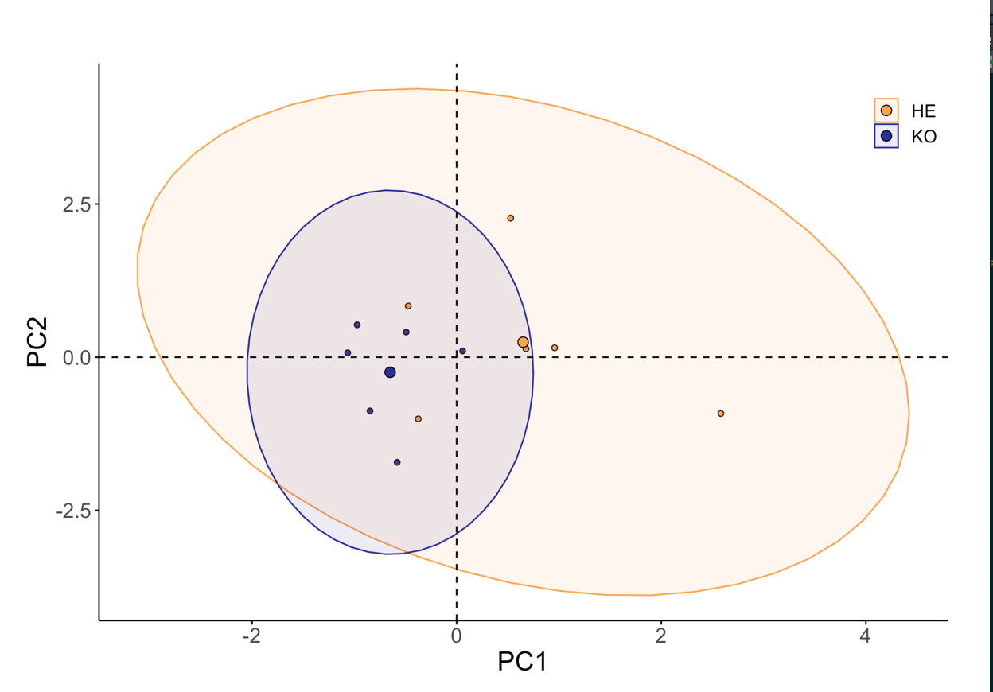**

**7.x Ordination of only 2019 measurements**

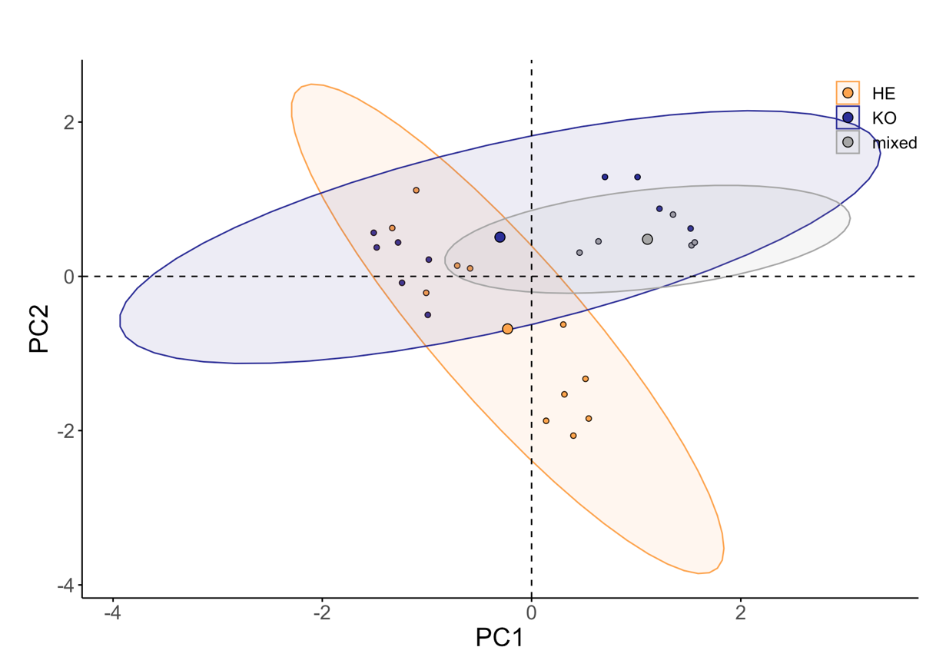

**7.x Post hoc alternate InStability Index (ISI) of bands across the spectrum, only using 2019 spectral signature, with more distinct endmembers**

****

**Figure 7.x Post hoc alternate InStability Index (ISI) of bands across the spectrum.** ISI values indicate how well bands discriminating vegetation types, with low values being more discriminative. Clear dots along the plotted ISI and the corresponding rugs indicate bands selected, via local minima selection. Background colors correspond to each region of the spectrum; blue 400-500 nm, green 500-600 nm, red 600-680 nm, near infra-red 680-800, infra-red 800-985.

**Table 7.x** Summary of alternate band selection ISI values by region,

|  |  |  |  |  |
| --- | --- | --- | --- | --- |
| Region | ISI | Mean ISI | Number of bands selected | Selected band ISI |
| Blue | 1161 | 21 | 6 | 125 |
| Green | 1044 | 18.3 | 2 | 38 |
| Red | 799 | 18.2 | 1 | 19 |
| NIR | 1326 | 18.9 | 3 | 56 |
| IR | 2218 | 20.8 | 13 | 270 |

**7.x Spectral diversity by Richness, evenness, and bare ground**

Coefficients:

Estimate Std. Error t value Pr(>|t|)

typeHE 0.092751 0.025274 3.670 0.00321 \*\*

typeKO 0.088424 0.028747 3.076 0.00961 \*\*

year2019 0.187232 0.027709 6.757 2.02e-05 \*\*\*

richness 0.054068 0.020584 2.627 0.02211 \*

evenness -0.003222 0.029593 -0.109 0.91510

bareground -0.028781 0.040306 -0.714 0.48886

typeKO:richness -0.052562 0.046501 -1.130 0.28041

typeKO:evenness 0.031668 0.052830 0.599 0.56003

typeKO:bareground 0.008350 0.046165 0.181 0.85949

**7.x Correlation plot between continuous variables in multiple linear regression model**



**7.x Correlation plot between spectral signatures and all environmental factors derived from point framing data and**



**7.x PCA of spectral signatures and all environmental factors derived from point framing data and**



**7.x Environmental factor biplot by year**

**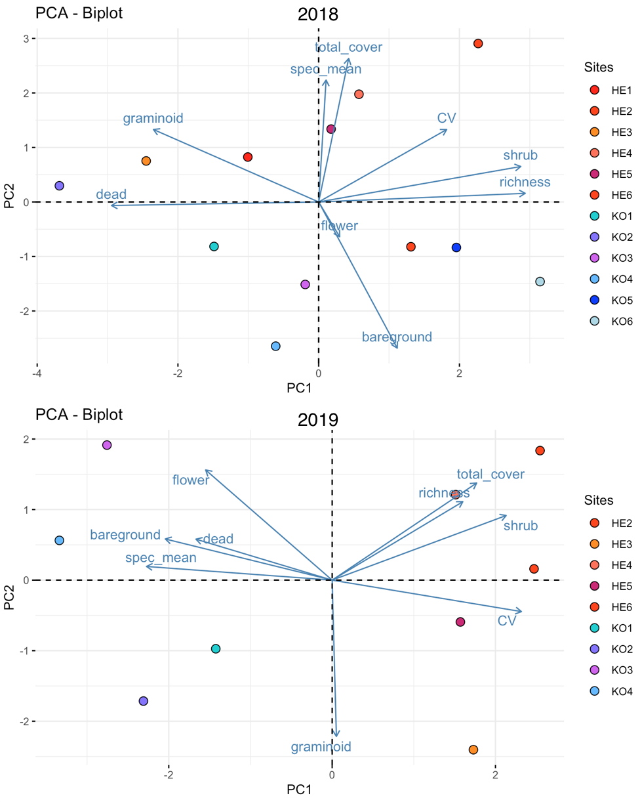**

**7.x Code for point framing**

**7.x Code for**

**7.x Packages used for all code**

For full code visit: https://github.com/schneidereits/Dissertation

References:

(ArcticDEM, 2018)

NOTES TO DELETE:

Methods

a GER 1500 field spectrometer, which covers a spectral range of 350–1050 nm, partitioned into 512 bands at a spectral resolution 3 nm, (spectral sampling 1.5 nm).

**3.3.3 ordinaiton of addiontal spectral factors**

Vegetation types discriminated from each other when ordinated. HE plots here heavily affected by diversity metrics (and total cover which is strongly correlated), as well as spectral diversity (corresponds with models). KO alined with environmental (visual) variables and mean reflectance (corresponds with models). (add mention relevance of direction)

Spectal had relatively close correspondence with total cover and could suggest that greater cover=greater canopy complexity=greater spectral diversity. For mean reflectance visable dead plant structure seemed to have a great effect and graminoid cover aswell.

Unlike previously when only ordinated according to visual properties, when environmental variables are added, vegetation types and year have slightly better visual discrimination. overlap of ordinated groups exists for at there interfaces (edges) of both measurements vegetation type and year. Overall measurments form 2018 where seen to be the most similar, with overlap to their respective vegetation type 2019 measurements. The largest discrimination in ordinal space was observed between 2019s vegetation type groups.

~~Very important, the trend and importance of variables only minimally changed when measurements where re-ordinated with the addition of 2018 data~~

Note how specific variables affect spec\_mean and CV

Roughly 2019 measuremtns aligned and discriminated along PC1, which strongly corresponds to/with mean reflectance. 2018 additonally varied with PC2, which corresponds to/with spectral diversity. (write about implication of this).

When ordinated with all available environmental variable percent dead cover, spectral diversity and bare ground were the three variables with the best representation in the first two principle components (cos2) (implies most important). Each on contributed equally to pc1 and pc2. Visuable flowering tissue had the weakest contribution in ordinating measurments filter

A high cos2 indicates a good representation of the variable on the principal component. In this case the variable is positioned close to the circumference of the correlation circle.

**4.2.1 discriminating vegetation based on mean reflectance and spectral signatures**

Mean reflectance being a stronger predictor of vegetation type may be explained by between types differences in reflectance being concentrated in only one region of the spectrum. Measurements were taken during the maximum canopy phenological phase, when vegetation tissue density and structure is most pronounced (Bratsch et al., 2016). Increased canopy and vegetation density predominantly amplify reflectance in the NIR and IR regions of the spectrum (Cavender‐Bares et al., 2017). These differences would be expressed in mean reflectance values but are not necessarily captured by spectral diversity.

Phenological phase may influence

Variation in spectral signatures across the growing season may influence the applicability of using spectral diversity.

The senescence phase is when differences in chemical properties, such as photosynthetic pigmentation are most prominent (Beamish et al., 2017). Pigmentation influences reflectance across the multiple regions spectrum resulting in vegetation types showing less differentiation based on their mean reflectance. Spectral diversity accounts for variation across spectral regions and would be the better metric for distinguishing vegetation types. Furthermore, at senescence, environmental factors such as visible reproductive tissue would I found negatively correlated with spectral diversity and have been shown to confound spectral diversity (Heumann et al., 2015), would be less pronounced. Quantifying how spectral diversity varies across the growing season, could provide insight into when vegetation types are most distinct in their spectral diversity, and could influence the success of predicting biodiversity. And the strength of the spectral diversity hypothesis

Previous findings indicate that information content-based metrics such as spectral diversity are better at discriminating vegetation types, as they account for complexity of reflectance patterns across the spectrum (cite).

Mean reflectance being a better predictor of vegetation type is possibly due to measurements being taken during the maximum canopy phenological phase, where vegetation tissue density and structure are most pronounced (Bratsch et al., 2016). As canopy structure and vegetation density predominantly affect (or amplify) reflectance in the NIR and IR regions of the spectrum (Cavender‐Bares et al., 2017), spectral differences would be concentrated at only one end of the spectrum. These differences would be expressed in mean reflectance values but are not necessarily captured by spectral diversity.

*Information content-based metrics extract information from the spectral space in a number of ways, for example, by calculating the variance of vegetation reflectance indices (e.g., NDVI) (Carlson et al., 2007; Gould, 2000****), the coefficient of variation derived from spectral reflectance (Wang et al., 2016a****), or the distance from the spectral centroid (Palmer et al., 2002).* ***Alternatively, information content-based metrics can be obtained from patterns in principal component spac****e, such as the distance from the centroid (Rocchini, 2007), which com- pacts spectral information and removes noise and band collinearity (Thompson et al., 2017).*

While vegetation type identification though spectral signatures was possible, my results highlight the complex

I predict that spectral diversity will have higher correspondence with vegetation types, as it captures the spectral complexity within each vegetation type (Wang et al., 2018). If spectral diversity has a higher correspondence with vegetation types, this means that the vegetation types discriminate based on overall spectral diversity, which is variable at all spectral regions and is influenced by compositional differences, such as biological, functional, and phylogenetic diversity.

Note that mean reflectance is not a great indicator, espically as you begin to consider more veg types, as differences as only dectectle if varation occurs at one end of the specure. Not high and low or somewhere more central.

If the mean of spectral signatures has greater correspondence with vegetation type, this indicates that the spectral complexity of a vegetation type is less important than between-type differences in spectral signatures. These differences would relate to course optical differences at specific spectral regions, resultant from a limited number of structural or chemical differences. The correspondence between mean reflectance and vegetation type is likely to be limited by spectral differences not being concentrated a one region of the spectrum. Spectral differences occurring at both low and high wavelengths, overall result in an in-between mean reflectance that is similar and does not account for internal spectral complexity.

The observed discrimi- nability of the senescence phenological phase could be explained by a combination of over- all lower variability in reflectance and/or comparable or greater differences in mean reflec- tance boosting the differentiability of these three communities from the other communities in comparison to leaf-out and maximum canopy (Table 2–4, Figure 2–3**). Previous charac- terizations of Arctic vegetation community reflectance spectra have suggested that distinct communities are spectrally more similar outside of the peak growing season but have not explicitly explored the influence or trade-off of accompanying spectral variability observed in the late season (Bratsch et al., 2016; Buchhorn et al., 2013).** To date, the late season represents a relatively unexplored phenological phase spectrally, and this paper shows that it has potential given the relatively low ISI values in the visible and red-edge spectrum, providing independence from the litter and water-sensitive NIR plateau for characteriza- tion. beamish

**My measurments were taken at peak growing season, which may have dimished spectral seperation**

MAT and ST are comprised of approximately 70% vascular plant and 30% non-vascular. MNT has the inverse composition, and MT composition is almost equal between vascular and non-vascular vegetation, and was the only vegetation community never misclassified at Ivotuk. During peak growing season, MAT was exclusively misclassified as ST, highlighting the importance of vegetation structure for tundra community discrimination during peak growing season.

**4.3.2 Does band selection improve differentiation vegetation types based on spectral signature?**

Band selections did not result a greater visual discrimination of vegetation types based on spectral diversity. I expected that band selection would improve MLRM predicted differences in mean reflectance and spectral diversity between vegetation types. Only modest visual improvements where observed in discriminating based on mean reflectance and spectral diversity was not affected by band selection.

**4.2.1 improtant spectral regions**

, due to the signicant differences in the graminoid vs shrub covers between the two vegetation types. KO tends to have greater graminoid cover, which tend to have complex leaf and stalk orientation and faceted canopy structure refract and interact with light in ways distinctly different the HE plots, explaining the distinct differences in NIR platou spectral region.

The NIR plateau 750-800 nm provided consistently low ISI bands and is a region that reflectcts “leaf cellular and canopy structure” (Beamish, 2019). (but also (Cavender‐Bares et al., 2017)

~~This region may have had low and stable ISI values, possibly due to differences in graminoid cover, between vegetation types. KO plots tended to have greater cover, which Increases canopy structure/ complexity and has been shown to have alter light refraction and interaction patterns and been shown to alter (Schweiger et al., 2017)(complex leaf and stalk orientation and faceted canopy structure),~~

Relative peak at 718-720 nm (NIR ridge) has the lowest discrimination potential (confirm by (Asner and Heidebrecht, 2002)

920-985 water sensitive NIR region

Partically xxx wavelengths for xxx pigments were relavent. This corresponds with xxx species, or higher shub cover, or high flower visability

i) entering vegetation types enter senescence different dates and ii) that spectral signatures are influenced by temporal variations in specific pigmentation concentrations at time of measurements, a trend observed in (Chavana-Bryant et al., 2017).

spectral signatures are influenced by temporal variations in specific pigmentation concentrations at time of measurements, a trend observed in (Chavana-Bryant et al., 2017). Furthermore this supports discussion xxx about senescence

Bs link to H1 peak vs sensence somehow

4.2.2 band selcetion model predicitons

Write about 3 point vs 5 point minima, and the inclusion of highly variable parts of the spectrum). (could look into 5 point window). Discussion this could significantly improve model accuracy. Especially as SZU implies less bands (ideally 3) are best.

But While other work has demonstrated that having distinct endmember classes are essential to providing accurate and discriminative bands selections, my results indicated that i) more band selection based on disntinct endmemebers (2019) did not improve the differentiation of vegetationand, ii) even when spectrally signicantly less distinct (2018 data), selected bands had close correspondence. When synethising this with the manual selection this may suggest that i) ISI is robust in its selection, even with suboptimal endmembers ii) arctic vegetation types are paticullly well discriminated at distinct spectral regions and that this trend holdes true across landscapes and quality of data, iii) or lack of applicability as it does not do much…

Discussion while theoretically have more distinct endmembers should result in a better selection of discriminative bands, it may be possible that the selection of only 2019 performed worse than the 2018+2019 selection, as measurements were so distinctly different that the spectral trends per vegetation type are not shared between years.

Selecting a subset of bands will result in better discrimination of vegetation types, as reducing spectral dimensionality excludes variable and noisy regions of the spectrum. Spectral mixture analysis using spectral zone unmixing will result in finding what zones of the spectrum are best suited to differentia vegetation types. This is achieved by isolating bands that explain maximum between community variability, while exhibiting the minimum within community variability.

4.4.1

Multi-year data may be helpful to separate the confounding effects of short term drought and anthesis on NDVI–biodiversity relationship because the seasonal meteorology can vary year to year. The exact impact of these multiple factors on the timing of the NDVI–biodiversity relationship, while beyond the scope of this study, might yield additional insights into the mechanisms driving the productivity–biodiversity relationship.

Remarkably, the NDVI-biodiversity correlation peaked at mid-season, a period of warm, dry conditions and anthesis, when NDVI reached a local minimum. These findings confirm a positive, but dynamic, productivity–diversity relationship and highlight the benefit of optical remote sensing as an objective and non-invasive tool for assessing diversity–productivity relationships.

Compared to the spatial patterns of biodiversity, less attention has been paid to the seasonal patterns of biodiversity [**[40](https://www.mdpi.com/2072-4292/8/2/128/htm" \l "B40-remotesensing-08-00128" \o ")**] (maggurn) or the effect of phenology on the ability to assess biodiversity with remote sensing. In our study, the NDVI-richness relationship was dynamic and the best regression between NDVI and species richness occurred near peak season, although the exact reasons for this deserve further study. This dynamic relationship was most likely affected by canopy development, as well as by prevailing conditions (mid-season warm, dry conditions) and flowering phenology (timing of anthesis). While both short-term drought and mid-season anthesis clearly reduced NDVI, their effect on the NDVIbiodiversity patterns was less clear, and could have even enhanced this relationship, as illustrated by the enhanced NDVI-biodiversity correlations at mid-season (**[Figure 6](https://www.mdpi.com/2072-4292/8/2/128/htm" \l "fig_body_display_remotesensing-08-00128-f006)**, **[Figure 7](https://www.mdpi.com/2072-4292/8/2/128/htm" \l "fig_body_display_remotesensing-08-00128-f007)** and **[Figure 8](https://www.mdpi.com/2072-4292/8/2/128/htm" \l "fig_body_display_remotesensing-08-00128-f008)**, **[Table 2](https://www.mdpi.com/2072-4292/8/2/128/htm" \l "table_body_display_remotesensing-08-00128-t002)**), or at least not interfered with it. Multi-year data may be helpful to separate the confounding effects of short term drought and anthesis on NDVI–biodiversity relationship because the seasonal meteorology can vary year to year. The exact impact of these multiple factors on the timing of the NDVI–biodiversity relationship, while beyond the scope of this study, might yield additional insights into the mechanisms driving the productivity–biodiversity relationship.

~~Features like graminoid cover that have significant influence on canopy structure seemed to be important influence of spectral properties~~ Another aspect of spectral diversity not fully considered in this paper is the impact of canopy structure on the species richness-spectral diversity relationship. The information provided by optical passive re- mote sensing data is limited to the uppermost layer of the canopy seen by the sensor. Therefore, understory vegetation is underrepresented, which is a limiting factor in estimating species richness even for low- statured ecosystems. Active remote sensing sensors such as Light impact of vertical and horizontal vegetation structure on spectral di- versity was beyond the scope of this study, but remains a promising direction for future research. (Gholizadeh et al., 2018)

In addition to the biochemical properties and vegetation structure of plants, another factor contributing to the species richness-spectral di- versity relationship is the impact of phenology (the variation of bio- chemical and structural traits of plants over time). Previous research (e.g. Shurin, 2007; Wang et al., 2016b; White et al., 2006) has shown that the species richness is dynamic and varies with time. One source of uncertainty not considered in our analysis is the varying phenology of different species within the same sampling unit (e.g. while some species have senesced, others remain green). Although the time of collecting proximal data in our experiment was coincident with the peak growing season and before appreciable senescence occurred, applying the same approach in other phenological stages or other ecosystems with dif- ferent successional stages requires considering the temporally dynamic characteristics of the species. (Gholizadeh et al., 2018)

Species evenness adds additional information on stand composition, which affects spectral variation. However, it is not clear how or to what extent species rich- ness, evenness, and composition affect the overall optical signal, in part because experimental approaches are difficult to apply in remote sen- sing studies due to the large spatial scales involved. Furthermore, soil is known to confound optical diversity estimation (Gholizadeh et al., 2018) and these effects (species richness, evenness, composition and soil background) can be scale-dependent (Wang et al., 2018) requiring studies to be explicit about the spatial, temporal and spectral scales involved. (Wang, Gamon, Schweiger, et al., 2018)

This explains the widespread and well‐known importance of the NIR region in vegetation remote sensing, but presents an interesting paradox that has yet to be fully explored: that we can often gain more insight about the functioning of plants by examining wavelengths that are not used in photosynthesis than by examining those that are.(Ollinger, 2011)

In reviewing knowledge about the factors affecting canopy reflectance, several interesting themes have emerged. In attempts to identify specific drivers of reflectance, uncer- tainties related to scattering presently outweigh uncertain- ties related to absorbers (pigments, water, etc.). This is perhaps because absorbers influence specific spectral regions and can be measured more easily than structural properties. Factors such as leaf anatomy and leaf angle distribution affect scattering over all wavelengths in ways that are diffi- cult to quantify. This presents a challenge for understanding reflectance in the NIR region, where multiple combinations of interdependent properties can yield similar patterns of reflectance. This does not necessarily restrict our ability to

In addition to the biochemical properties and vegetation structure of plants, another factor contributing to the species richness-spectral di- versity relationship is the impact of phenology (the variation of bio- chemical and structural traits of plants over time). Previous research (e.g. Shurin, 2007; Wang et al., 2016b; White et al., 2006) has shown that the species richness is dynamic and varies with time. One source of uncertainty not considered in our analysis is the varying phenology of different species within the same sampling unit (e.g. while some species have senesced, others remain green). Although the time of collecting proximal data in our experiment was coincident with the peak growing season and before appreciable senescence occurred, applying the same approach in other phenological stages or other ecosystems with dif- ferent successional stages requires considering the temporally dynamic characteristics of the species. (Gholizadeh et al., 2018)

ADD mixed veg and PCA? and the inability to discriminate (mixed plots) based on their spectral properties,

4.2.3 discrimination in ordination

High heterogeneity in community-scale vegetation composition, soil moisture, and an abundance of litter and non-vascular components complicates interpreta- tion of NDVI and other broadband VIs in sparsely vegetated areas and outside of the peak- growing season (Liu et al., 2017). Buchhorn et al (2013) found that surface moisture re- duced reflectance in the NIR, in turn underestimating the biomass signal of low-Arctic tundra. Further, van Leeuwen and Huete, (1996) have demonstrated the importance of standing litter and soil in the interpretation of biophysical parameters. These results suggest that the small-scale heterogeneity of Arctic tundra vegetation and other internal ecosystem components are not well characterized at non-peak times, limiting our ability to gain a complete and detailed picture of vegetation change in the Arctic.

Communities are often broadly divided into moisture regime such as xeric (dry), mesic (moist), or hydric (wet), and soil acidity (acidic, non-acidic) and then further divided depending on the species complexes present (Walker et al., 2005, 1994). Often the same species can be observed in multiple distinct complexes as different phenotypes. Large homogenous patches of one or two species rarely exist outside water tracks, disturbed areas, or dry uplands where erect and prostrate dwarf shrub species dom- inate. This combination of small-scale heterogeneity in vegetation composition and soil moisture as well as the prostrate nature of tundra species leads to highly mixed, variable, and often similar spectral signatures between distinct vegetation communities. The some- times-dominant presence of non-vascular components (mosses and lichens) and barren ar- eas also contribute to the unique spectral signatures of tundra landscapes (Hope et al., 1993). This high spectral similarity can be observed with ground-based Visible-Near Infra- red (VNIR) remote sensing data making spectral separation challenging (Bratsch et al., 2016; Buchhorn et al., 2013; Riedel et al., 2005).

Soil reflectance is highly sensitive to moisture and roughness (Jacquemoud et al., 1992; Pinty et al., 1998) and its re- flectance can vary within and across study sites and through time. Therefore, the spectra extracted from one site (or image) may not be applicable to another site and another time

**Xxx Comparison between manual and automatic selection**

I found there was a general correspondence between bands included in manual and automatic selection. My manual selection was based on bands identified In other work to be associated with key biological functions in Arctic vegetation (Beamish, 2019; Bratsch et al., 2016; Buchhorn et al., 2013) (cite). Automatic band selection yielding similar subset of may suggest that spectral regions important for discriminating vegetation are similar across different sites with Arctic tundra vegetations. This implies observed trends of bands that are best suited to spectrally discriminate vegetation generalizable across sites.

These results from a prairie ecosystem near or during the peak growing season might differ from those from other ecosystems that differ substantially in species traits or from results in similar ecosystems at different times. Our results imply that, for biodiversity mapping, we can focus on spectral regions that cause heterogeneity in reflected radiation and are sensitive to factors such as leaf biochemistry, structural parameters, and phenology of plants, rather than using all bands. However, the exact influence of these factors is likely to vary with species type, environmental conditions, and time (Chavana-Bryant et al., 2017; Feilhauer et al., 2017; Filella and Penuelas, 1994; Gitelson and Merzlyak, 1997; Roberts et al., 1998). Therefore, identifying key wavelengths and plant traits for biodiversity applications is a complex, multidisciplinary effort that requires a deep understanding of remote sensing, ecology, and plant physiology. The effort is constrained by issues such as temporal resolution of the data, lack of data on species traits over time and space, and the challenge of data fusion at different scales (Jetz et al., 2016; Ustin and Gamon, 2010). Considering oppor- tunities afforded by forthcoming spaceborne hyperspectral sensors, such interdisciplinary efforts are needed to significantly improve our ability to use these sensors to obtain biodiversity information. (Gholizadeh et al., 2018)

The resulting wavelength selection from the ISI minima technique in the most discrimina- tive phenological phase of each community predominantly identifies vegetation colour, driven by vegetation pigment concentration, as discriminative spectral regions for identifi- cation of specific communities. The identification of senescence as a discriminative phe- nological phase is particularly interesting, as the communities are visually most distinct at senescence when carotenoid (yellow to orange) and anthocyanin (red) pigments begin to dominate and chlorophyll (green) pigments are degrading. With the exception of DT, all communities had equal or greater wavelength selection in the combined visible and red- edge spectrum than the NIR. **Slope and position of the red edge has been directly related to chlorophyll content in vascular plants (Filella and Penuelas, 1994)** **(maybe link to phase shift between 2018 and 2019) (difference between years & time of measurement)** and this paper is in agreement with previous and well-established research linking absorption in the visible spectrum to vegetation colour and pigment concentration (Curran, 1989; Gitelson and Merzlyak, 1997; Gitelson et al., 2002; Stylinski et al., 2002; Ustin and Curtiss, 1990) but brings new insights to the potential of the senescent phase for optical discrimination of low- Artic vegetation.

Although my results showed no difference between in the improvements to differentiation vegetation types provided by dimensionally reduced manual and automatically bands, persistent issues such as noise reduction would are addressed in manual selection (Jia et al., 2012)

Furthermore, if SZU results in the selection of bands that correspond with and/or are not visually better than an informal literature derived selection of spectral bands, this indicates that structural and chemical differences may be relatively convergent between different Arctic vegetation types. Furthermore, this is promising for the development of future satellites, as potentially selection of spectral regions may be sufficient to discriminate vegetation types.